Story Telling -- https://maximosecrets.com/portfolio/maximo-overview/17/

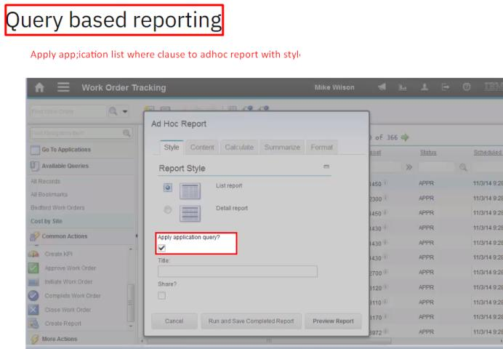

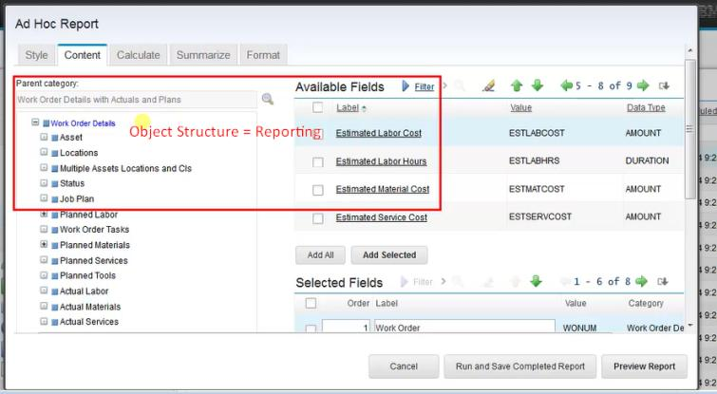

Expression gives out the result based on the operation and stored it in on col.
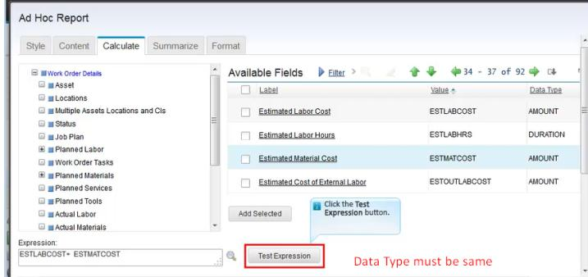
Summarize Tab
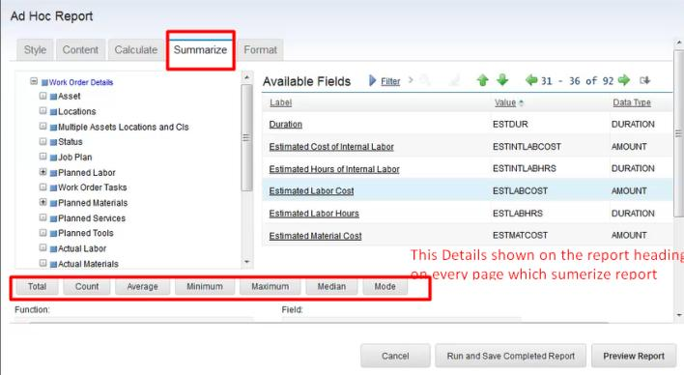
Preview Report – Changes reflect before save.
Run and save the completed report 🡪 It will permanently save it in the REPORT table.

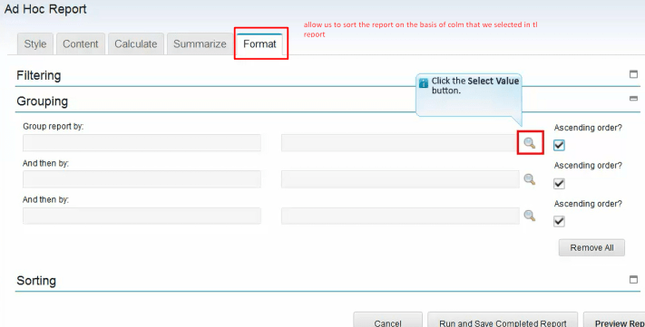
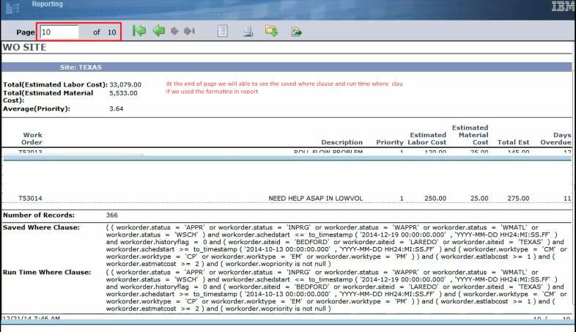
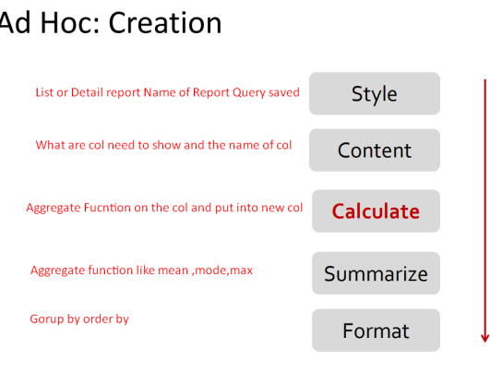
Hover over- to make hover dialog we must do the following thing.
- Modify the system xml rechover
- Define hover over xml re-import the XML back in Maximo.
- Select an attribute and give the hoverid in the advanced section save the application.

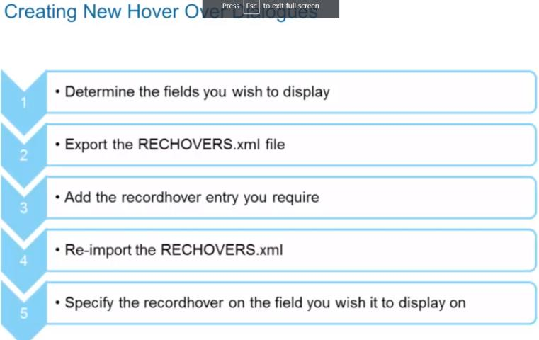
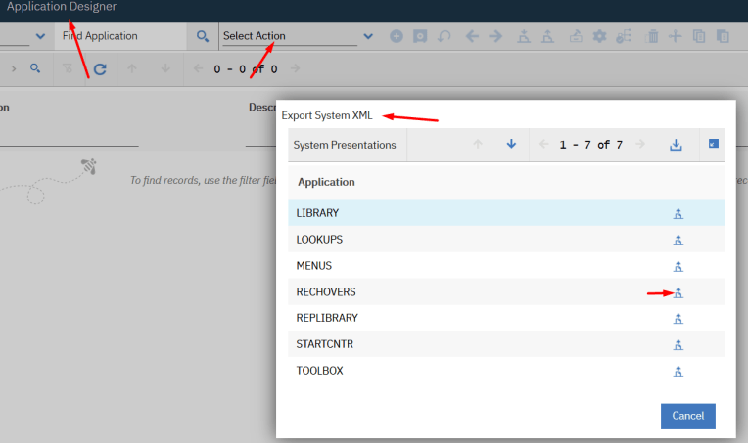
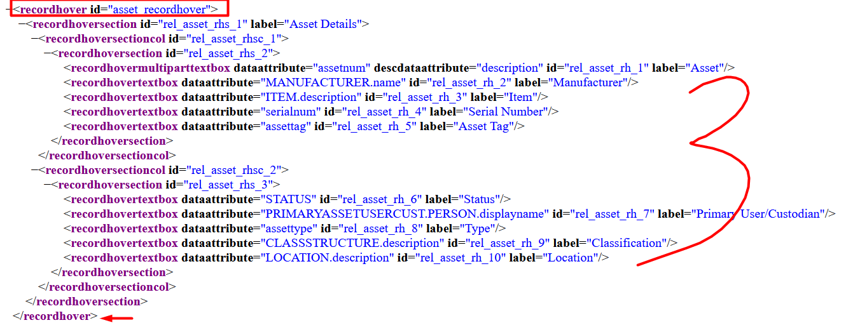
Reimport this XML back to maximo
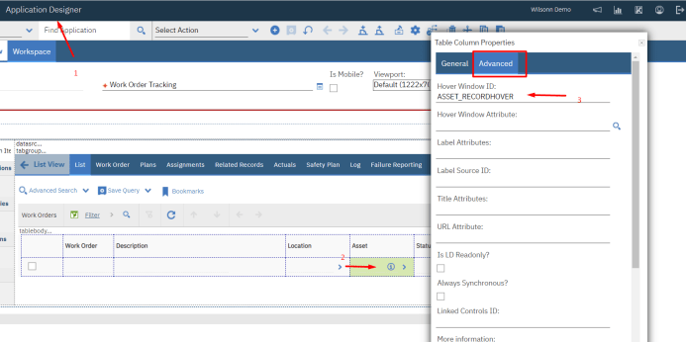

New Feature – Automation Scripting
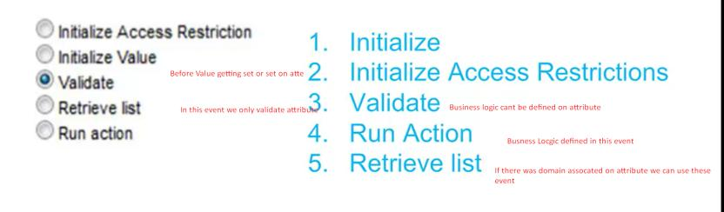

Edit Mode in Maximo
To Prevent the same record from being edited at the same time by different user
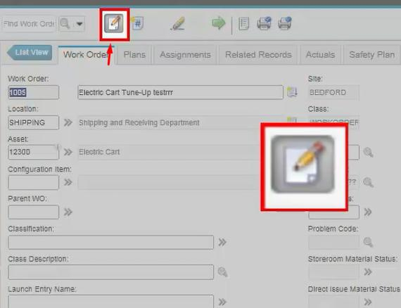

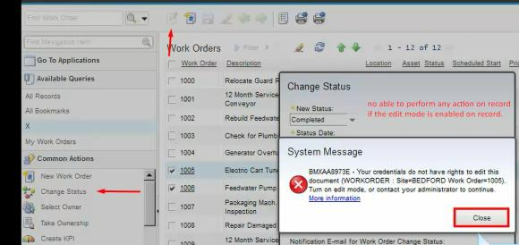
Record Release application used to release records.

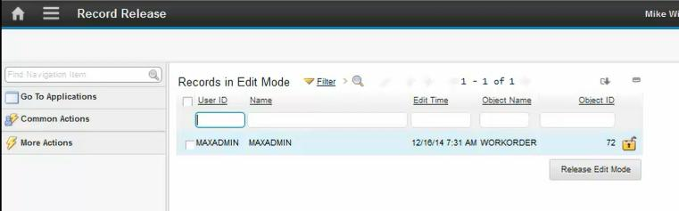
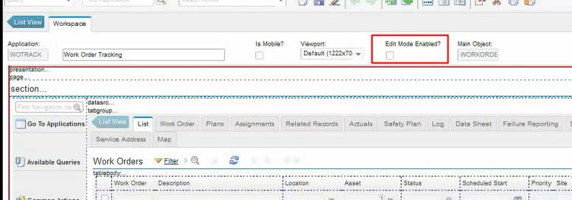

Crew
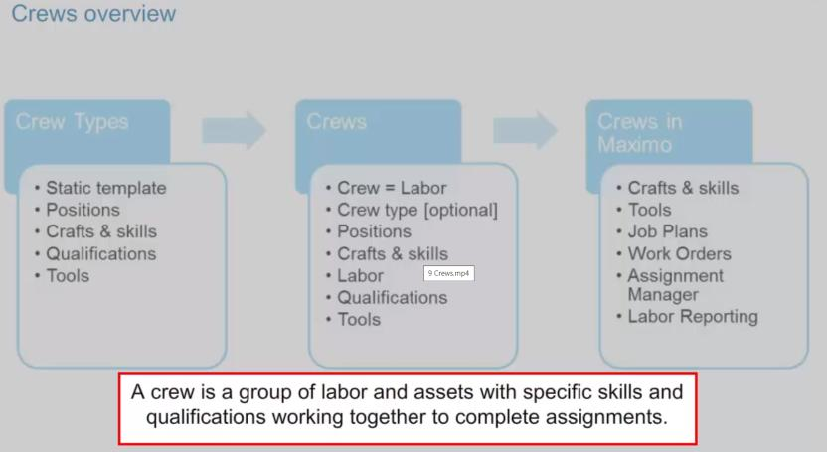

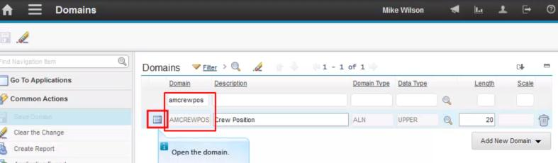

Crew Position is the domain and from that lookup value only we will be able to select the crew type and assigned labor for it.
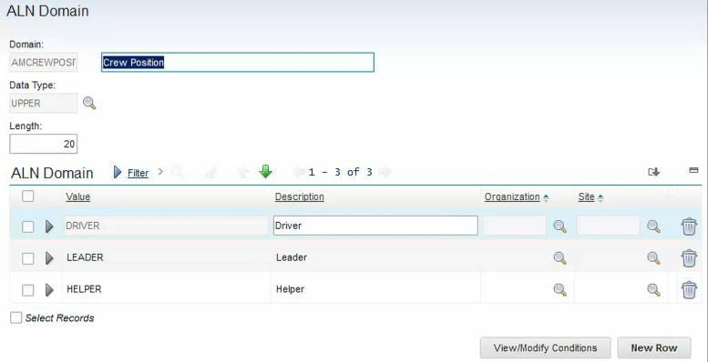
Crew type 🡪(Position defined in ALDOMAIN) Craft and craft skills come from the craft rate table.
Crew 🡪 CUST_CRE
Domains And lookups
ALN – Value list domain
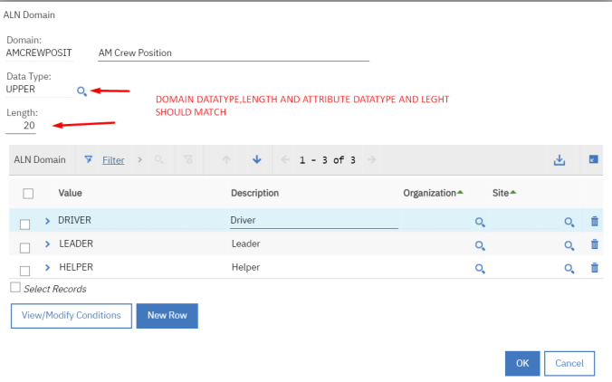
Apply the domain over attribute and configure select appropriate lookup or customize lookup as follow
Using lookups.xml in the app designer
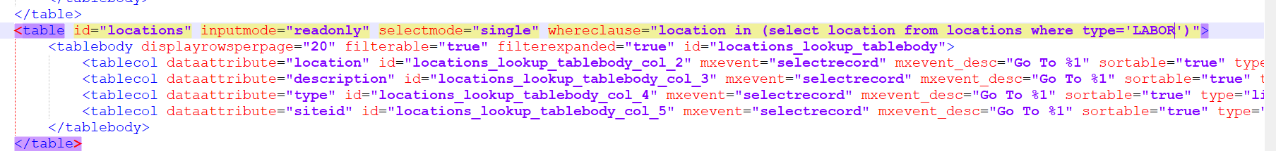

Cross-over domain 🡪 It’s just like a table domain which gives the list of values from the table based on validation and a list where clause. Plus, it also mapped some fields from that source table to the destination.
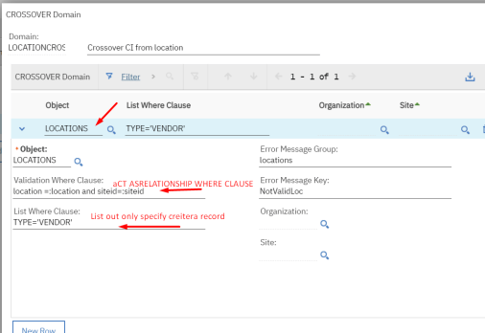

Numeric domain -- Specific number range in which we cannot be able to apply the custom message.
List of numbers 🡪 Priority 🡪 Value list 🡪 we can be able to set conditions on this.

Numeric Range domain – same as the numeric domain but here we can be able to define the sequence of the number.
Segment-wise range 🡪 No Lookup 🡪 No system messages 🡪 No Condition
An attribute must be in smallint type
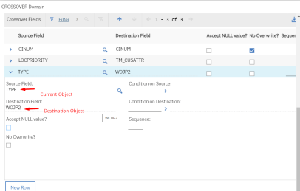

Table Domain: Get the dynamic value from that table with validation where clause and list where clause.

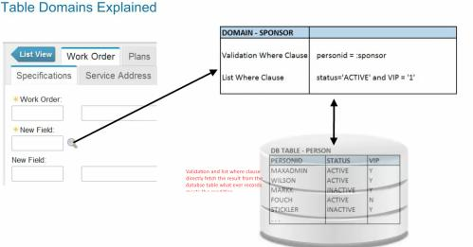
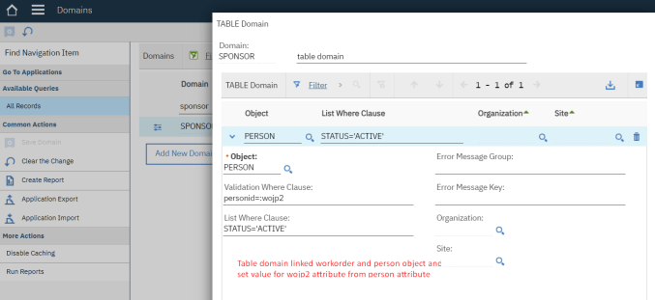
Associate domain to wojp2 attribute and config DB
Synonym domain
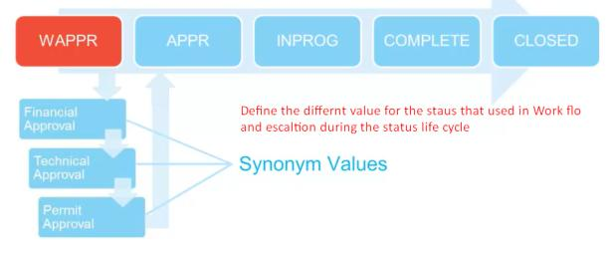
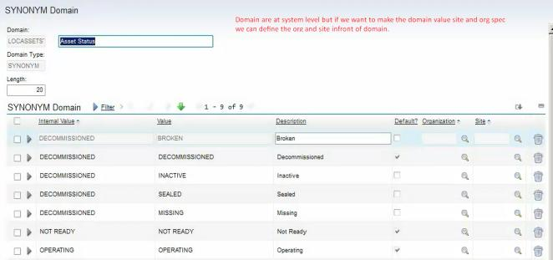
We can add the condition on the domain value.
Numer, Synonym domain 🡪 We can add condition 🡪 No custom message.
Numeric range 🡪 No condition No message.
Table, Cross Domain-> No Condition but we can give a custom message

Maximo Cluster System This Configuration can be done in the maximo.properties file while installation and need to redeploy EAR for each application.
- UI server – user can access the system from a web browser.
- MIF Server - This cluster uses Java Message Service (JMS), Hyper Text Transfer Protocol (HTTP) POST commands, web services, and Enterprise JavaBeans (EJB)
- Cron task - processes scheduled jobs, integration tasks, escalations, and LDAP which help to trigger the event. Ex Run report.
- Report- BIRT Report Engine

https://www.ibm.com/docs/pt-br/SSLKT6_7.6.0/com.ibm.mbs.doc/pdf_mbs_sysadmin.pdf
Levels of Object 🡪System – sets – Org – site.

Indexes You can use indexes to optimize performance for fetching data. Indexes provide pointers to locations of frequently accessed data. You can create an index on the columns in an object that you frequently query.
Backup Maximo Database
Database Configuration
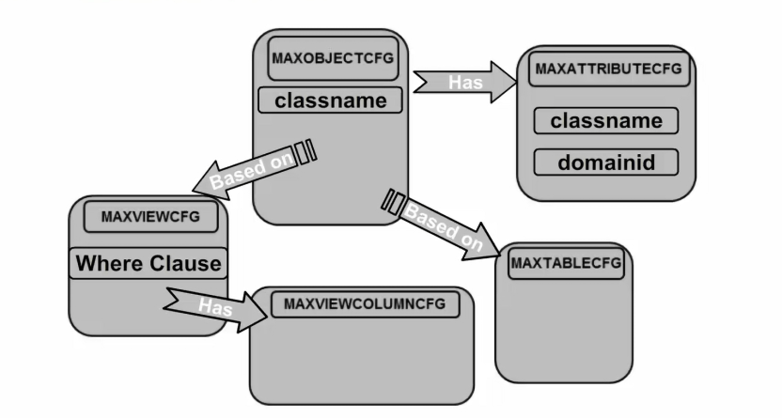
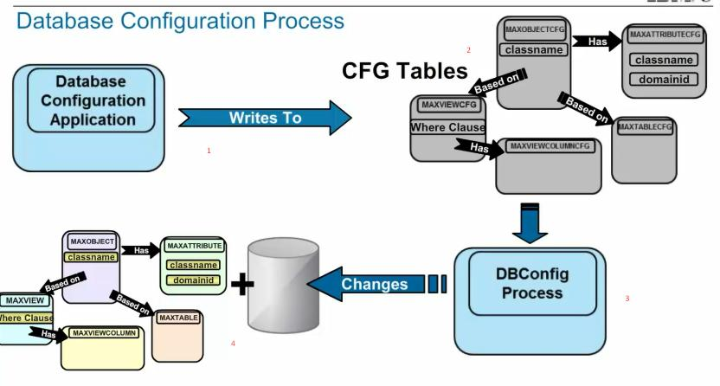

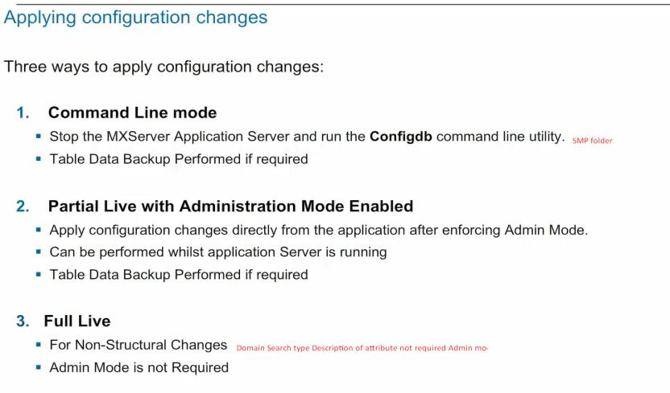
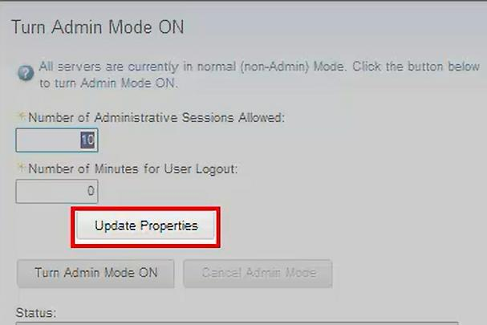

Defaulting value in Maximo
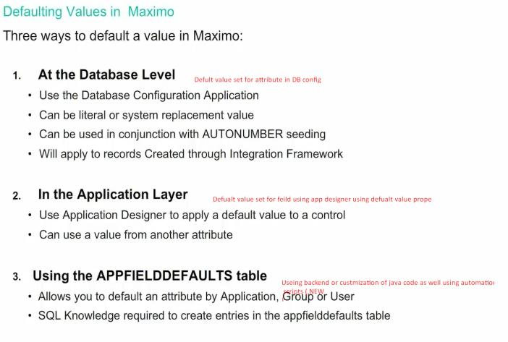
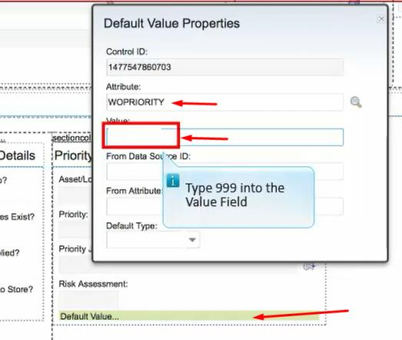

Creating Messages:
Used in Automation script and Domain.
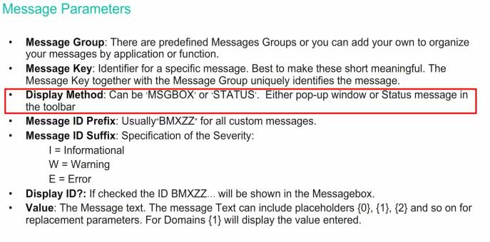
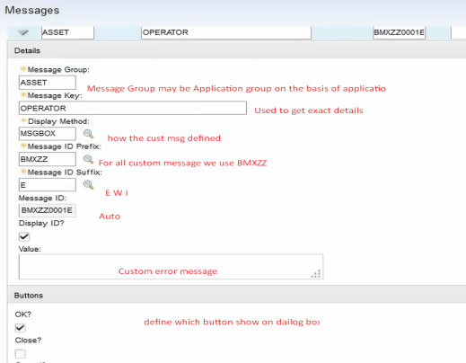

Audit Enabled:
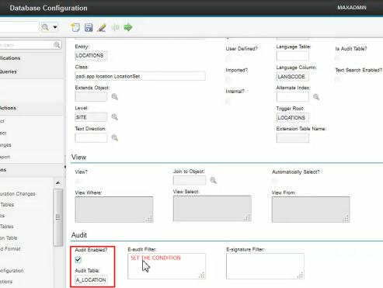
Need to created Relation between these tables
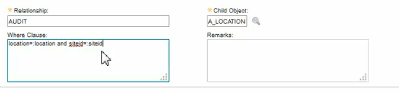

E- Signature
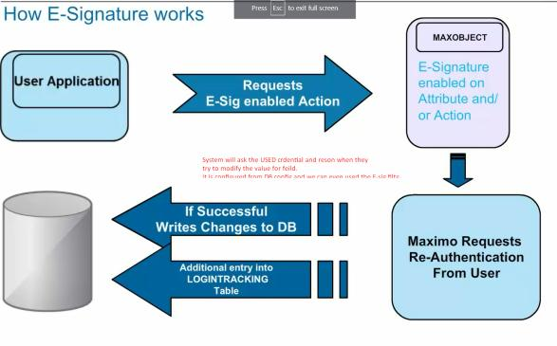
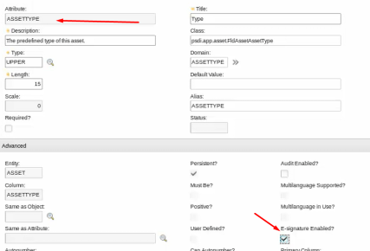
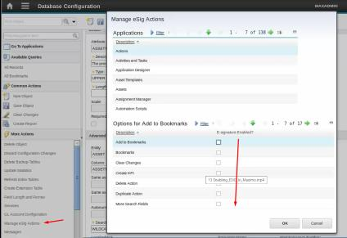
We can apply filter on record as well.
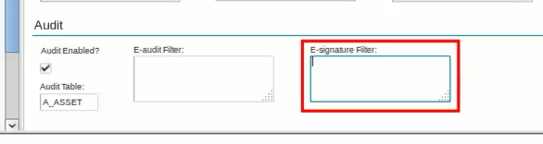
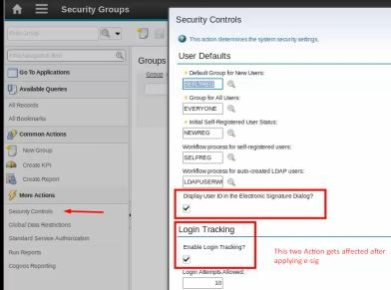
SQL Getting Started 🡪 CRUD Operation of DB, Joins subquery

Security Group Configurations
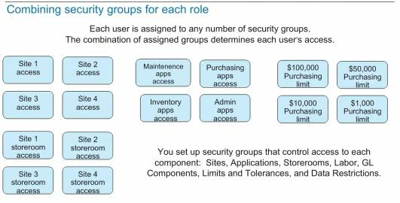
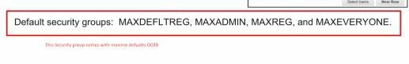
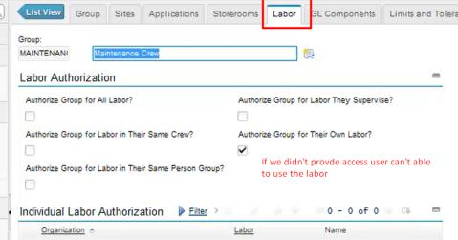
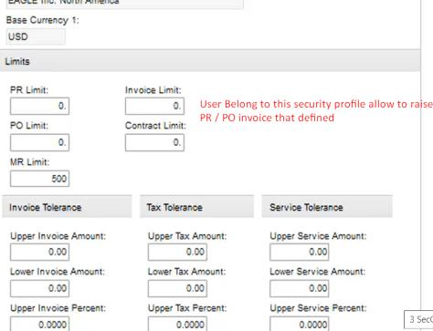
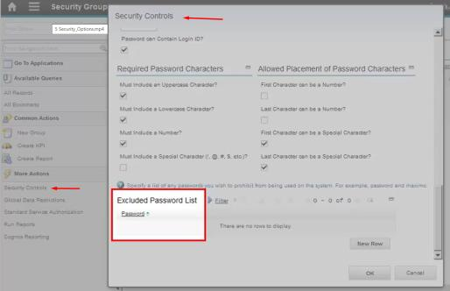

Application Development
All Maximo applications built using application Designer will be stored in the MAXPRESENTATION table.
We can modify this XML and import it to the Maximo app designer MAXAPPS.
Control pallet: used to design applications that contain various components like section table field. Later we can configure it as per our business requirements.
Each control used in an application has its unique identity.
How application XML will be shown to the user on web
presentation.xml 🡪 Retrieved 🡪 process started in application server 🡪 for each XML control code server create the HTML description 🡪 and rendered in an incremental manner 🡪 Once everything is rendered application server saves the HTML in memory and pass to Web client.
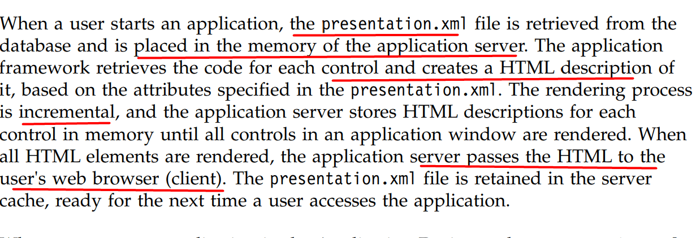
Application Organization
Module 🡪 Application
Types of Application in Maximo

- Power Application 🡪 standard type of application that contains multiple tabs, a Select Action menu and toolbar buttons. Ex. Work order Tracking
- Self-Service🡪 It is used to create a record and does not include a List Table window or a toolbar.
It is only the User form that they fill out and submit.
Ex - User Self Registration, Create SR only form no action no tab
- Single-Page🡪 used to create a record and does not include a List Table window or a toolbar.
Ex Condition expression manager, view
Presentation 🡪 Application overview
Page 🡪 Tabs in application
Dialog🡪 We can create a dialog in the Maximo application by importing the application XML and access re-import that XML and accessing that dialog using the edit dialog action in the application designer.
Section🡪 Container we can use as much as we want.
Tab group🡪 To Navigate to another page of the same application with the same record. (log [worklog/comm log])
Table 🡪 To show the child records associated with the current parent record. [task work order on the main work order]
Push the button group to associate the new record with the parent.

Data validation in Application🡪
Server-side validation🡪
- Asynchronous 🡪 At the time of Save Disabled by default.
- Synchronous 🡪 Values are validated when they are entered and tab out from the field.
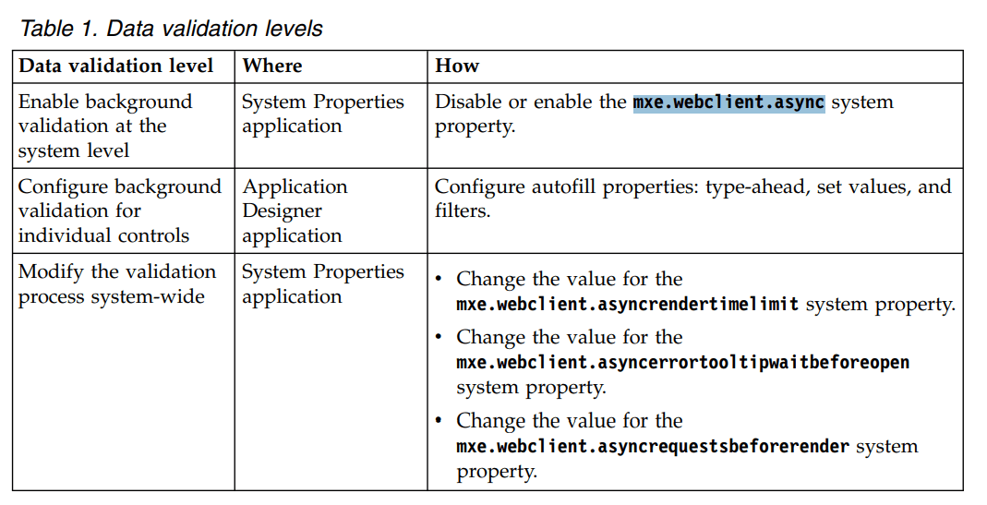
Best practices for data validation types
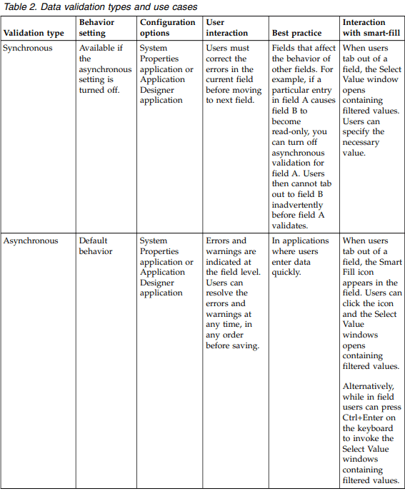

We can’t be able to delete the OOB application from the application designer.
We can only delete applications created or duplicated by the application designer from the UI as well as from the Backend.
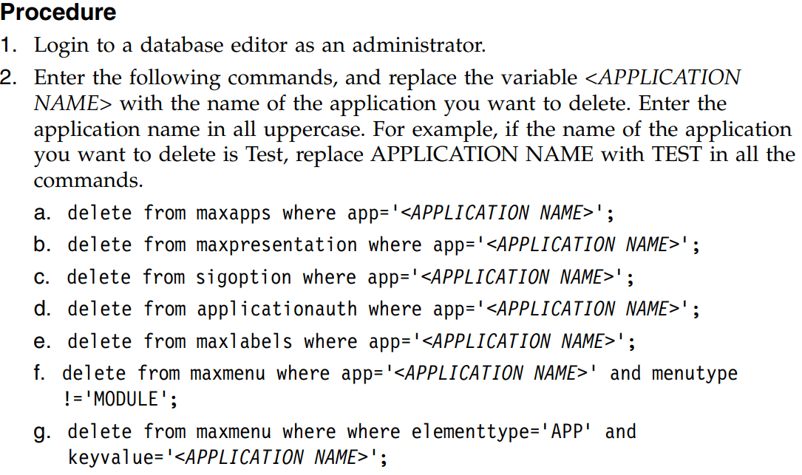
Application Restriction:
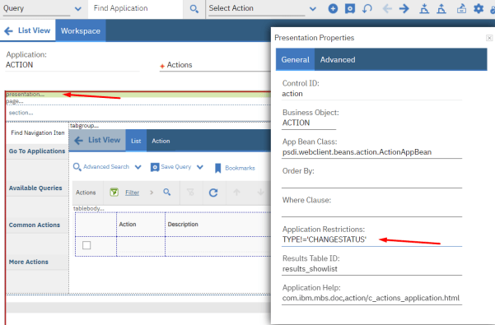

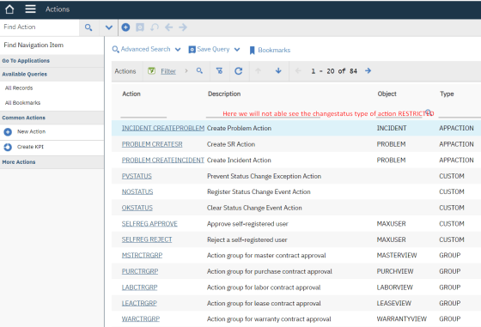
Controlling the size of fields
Using properties
Using -field-size-config.xml at the system level
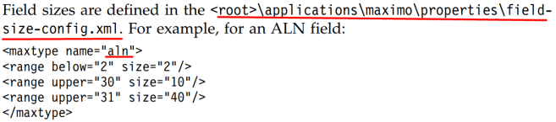
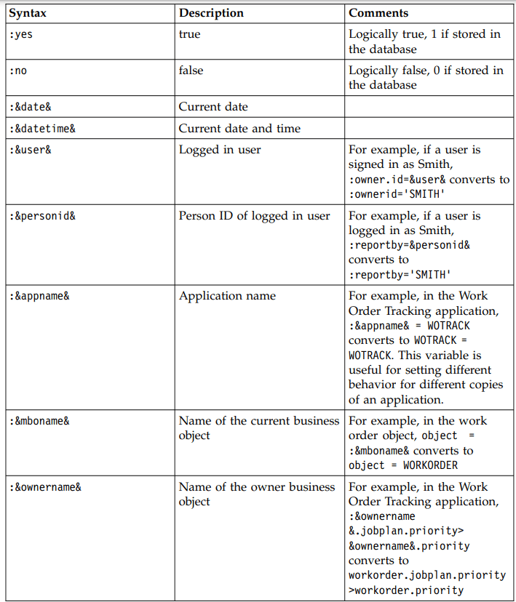
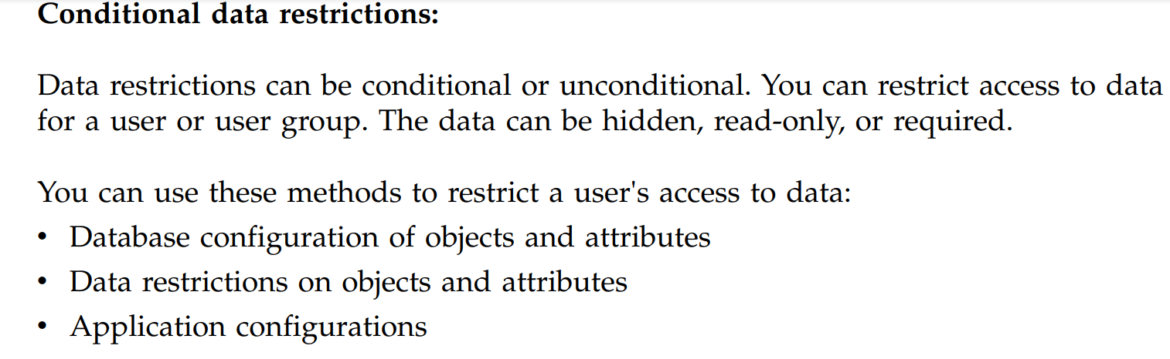
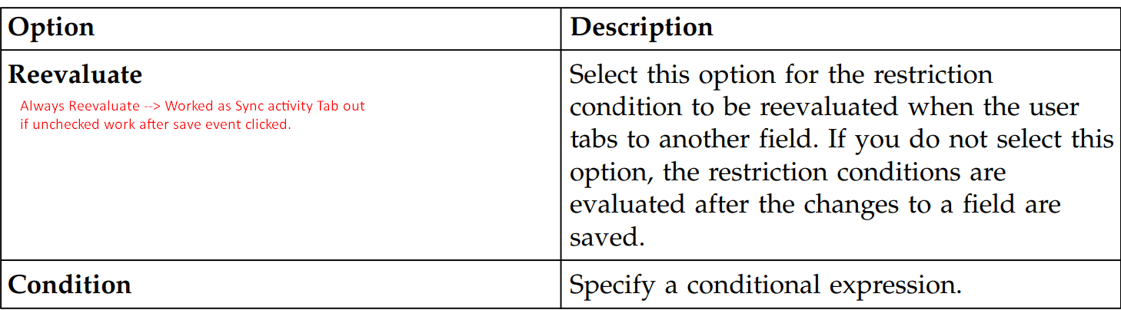
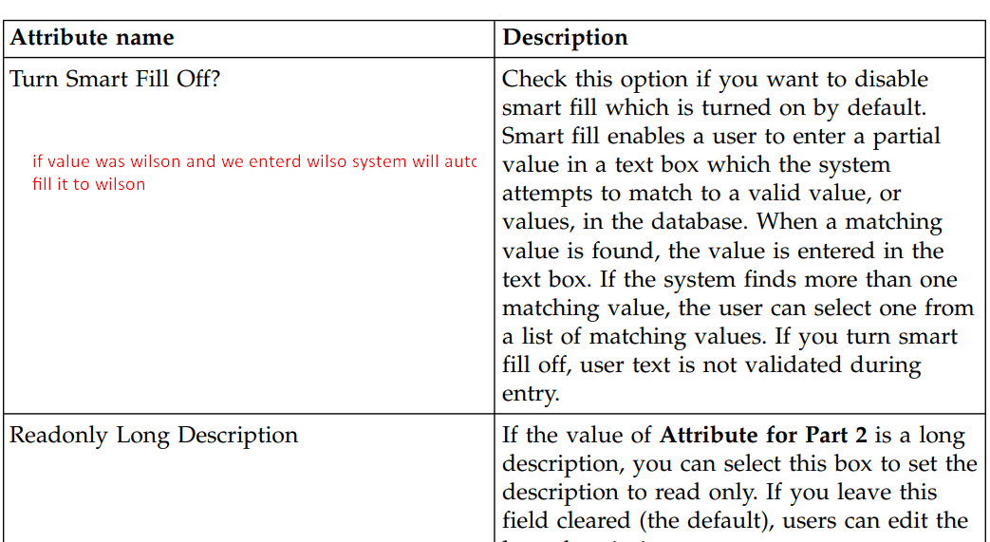

Application designers select records.
It is configured on table-level properties as follows by providing an event.
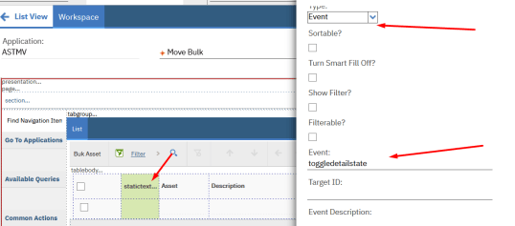’ 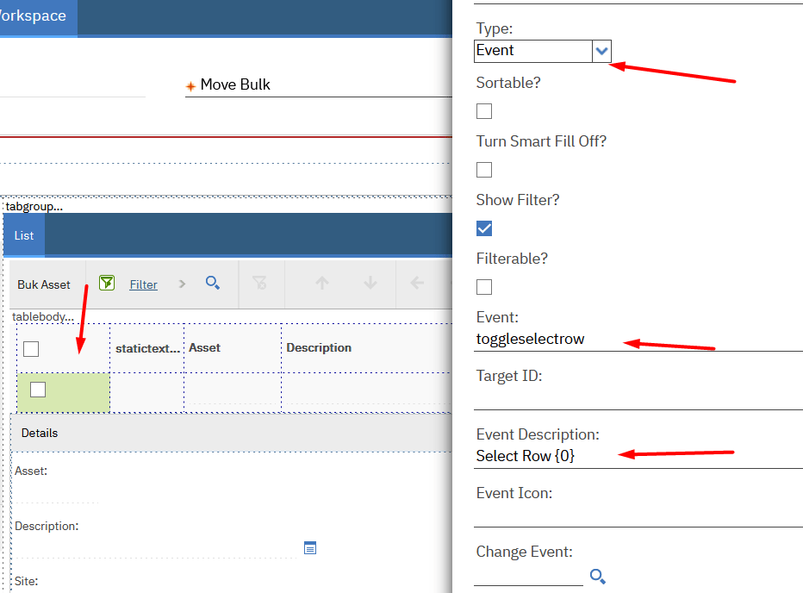

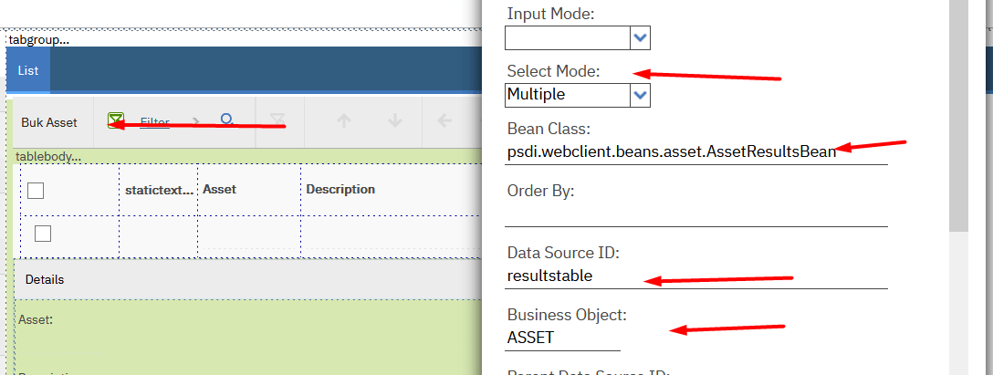

The following application is used when defining workflow.

Action🡪 Automation Script🡪 workflow designer 🡪 Communication Template🡪 Role 🡪 inbox assignment.

links -- https://maximosecrets.com/2017/02/07/maximo-applications-1-of-4/
Module 3
Asset Overview
Life Cycle :
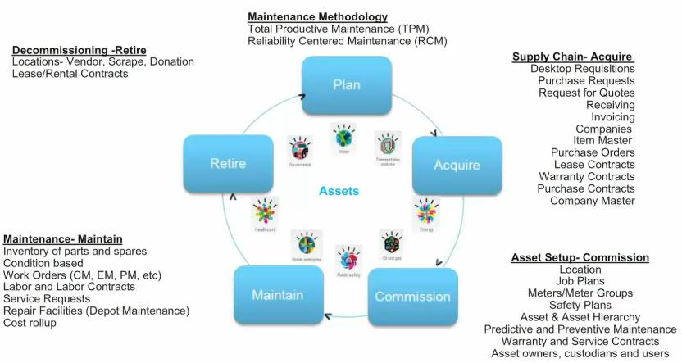
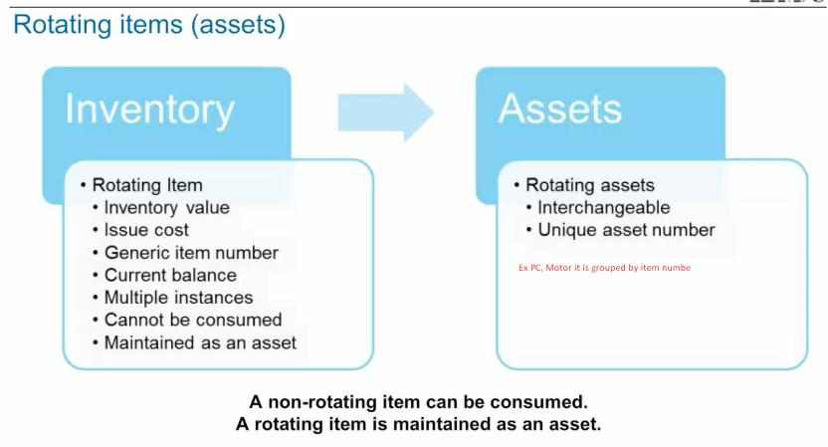
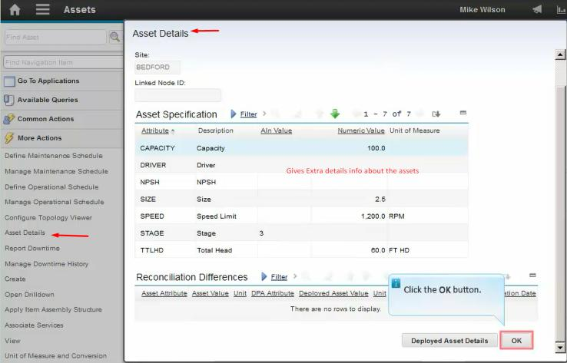
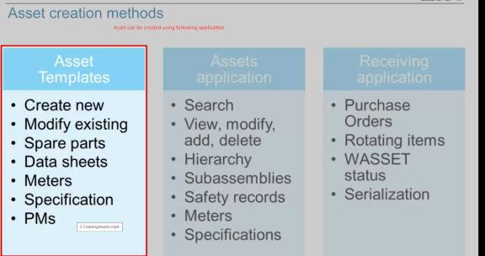
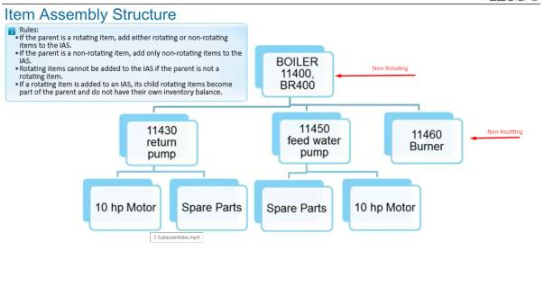
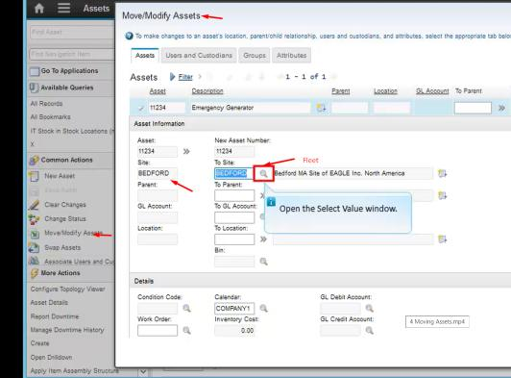
Move assets to another location or site.
Moved the check box checked and the status at this site changed to Decommissioned.
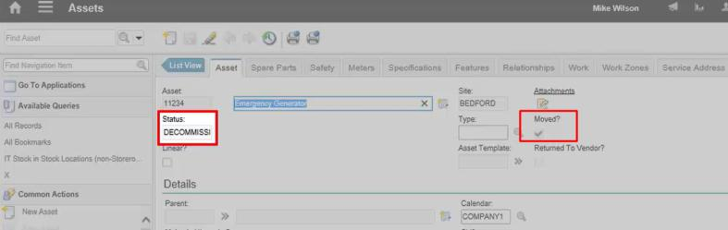
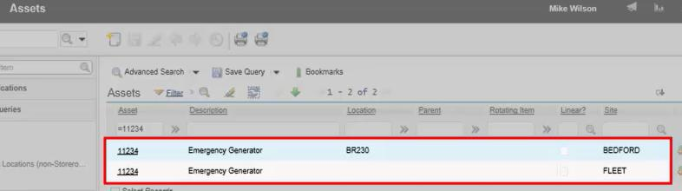
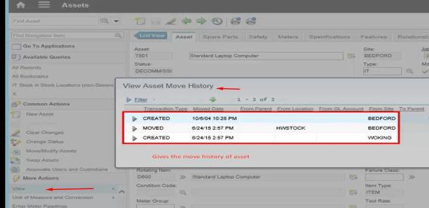
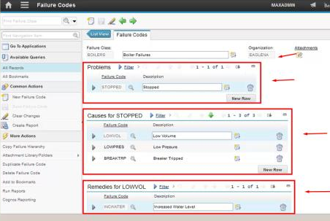

Automation script
https://ibm-maximo-dev.github.io/maximo-autoscript-documentation/introduction/whatisautoscript
JSR – Java specification request allow Maximo to install to host script engines compliant with this specification like
Maximo is a JAVA application that allows us to run the script in Python/Jython engine and run it.
Jython and Python are the same and give the same output in the system.
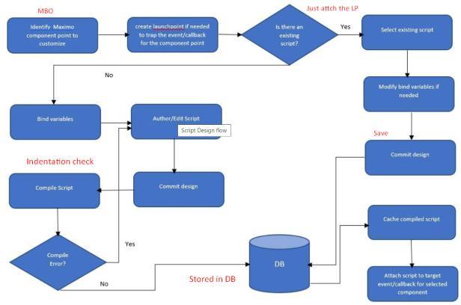
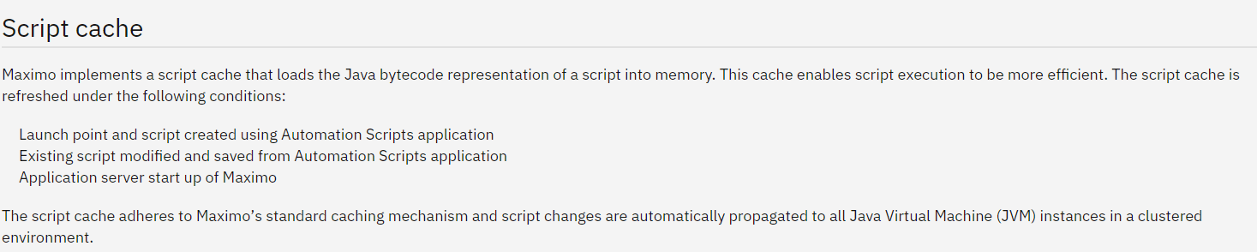
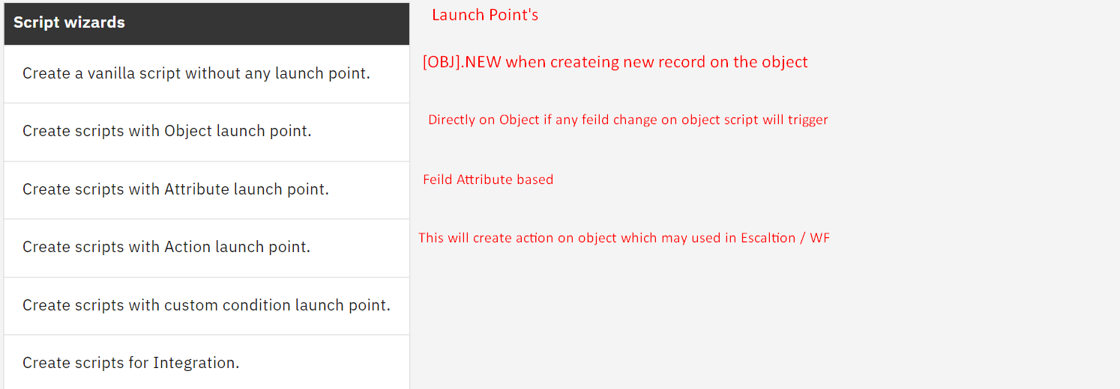
Condition Launch Point🡪 Security group restriction and workflow condition evaluates to True and false.
This applies also to the sig option for operational new row records Ex if the business wants only one meter for an asset, we can hide the new row button after adding 1 entry.
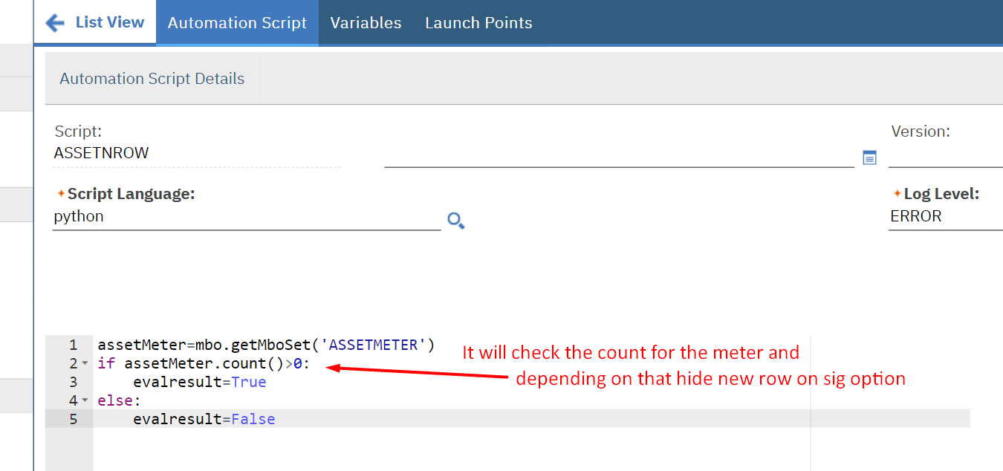

Implicit and explicit variable
https://ibm-maximo-dev.github.io/maximo-autoscript-documentation/introduction/components
Most Imp
https://www.ibm.com/support/pages/overview-automation-script-launch-points-and-sequentially-ordered-automation-scripts

User Info in Maximo using automation script
https://www.maximoscripting.com/the-userinfo-object/
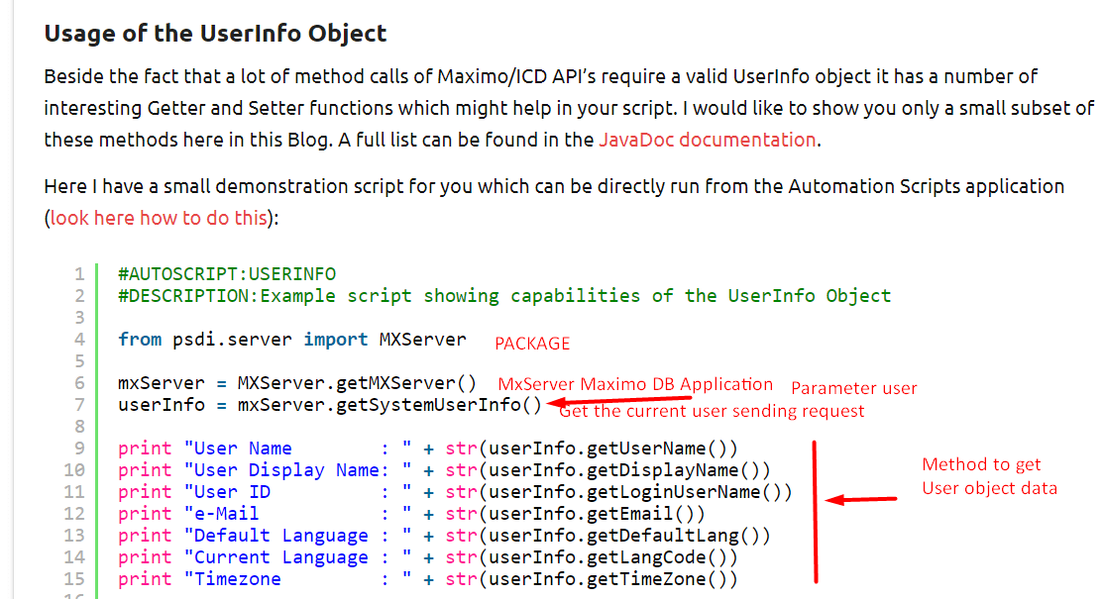

Implicit =Maximo global variable which contains dynamic data from the (Keyword in simple language)
Ex.app, user, mbo, mboname, error key, interactive, launchPoint, service
Explicit = variable which we define as part of our logic and which contains the value that we are getting setting or stored in variable

Launch Point and callback (trigger points)
A single script may have 1 or more that launch points which either an object /attribute
- MBO initialization and save point logic or Object launch point
- MBO attribute value modification – validation and action logic or Object attribute launch point
- Actions, which are used by many other components like Workflow, Escalation, UI Menu, UI Buttons, or Action launch points.
- Custom conditions used by Workflow conditions, Conditional UI and others or custom condition launch point.
MboConstants.NOACCESSCHECK 🡪 2L
Object Launch point.
Event’s
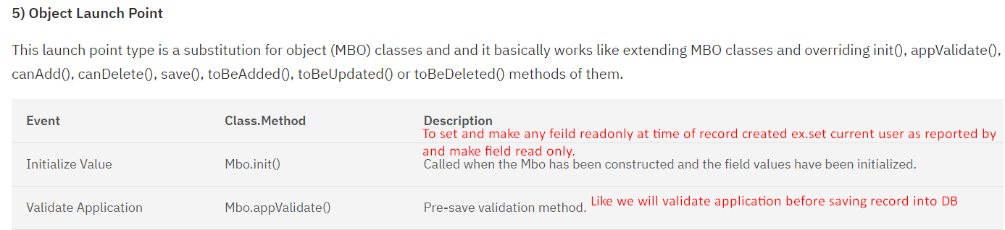
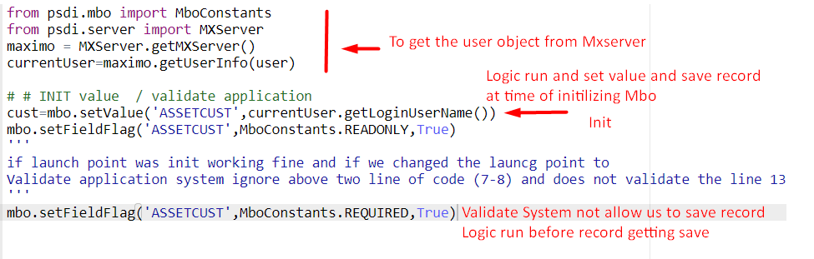

Init Value🡪 it will use to make the field read only / required. While performing action on that mbo record. It will work on new record as well as old record which existing in database.
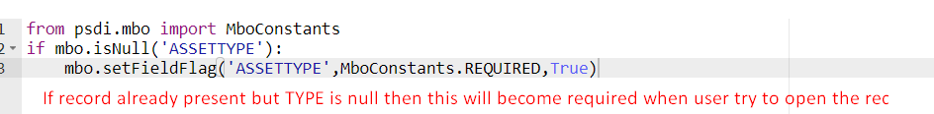

Validate Application
This Event will work for both newly created record as well as existing record in maximo
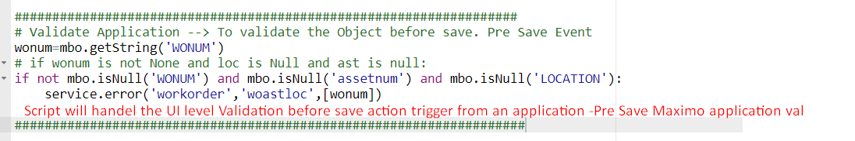
Use case –WO can be raised on Asset or Location but if user put both blank, so we must stop Maximo saving record since it is senseless to raise WO without Location or asset. And also, user can’t able to create the WO on both location and asset same time so that time this work.

Allow Object Creation 🡪 Script LP (allow obj creation)🡪 Object 🡪POLINE🡪
In this example we are trying to create a POLINE on PO without having vendor associated system throw error Since the we do not have POLINE mbo so we can’t directly access the Owner whiteout child reference so that the reason we are fetching the owner form POLINE object set directly.

owner = mboset.getOwner() #action performed on POLINE object i.e why we get owner from the current set (poline)
if owner is not None and owner.getName()=="PO" and owner.isNull("vendor"):
service.error("PO", "vendor is null")
Script triggered when user tried to create new record (NEWROW) Event

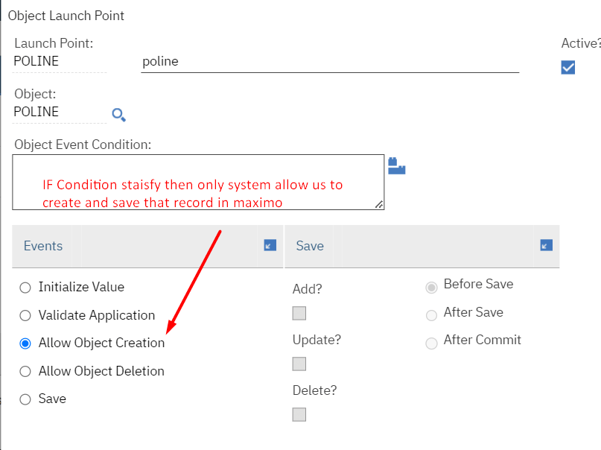
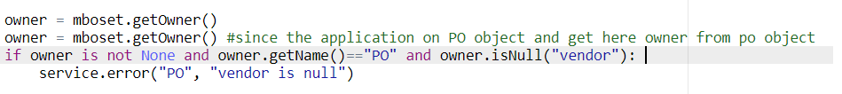

Allow Object Deletion
We can define rule before doing delete operation on mbo.
Ex if any PM having WO generated system won’t allow to delete that PM record.
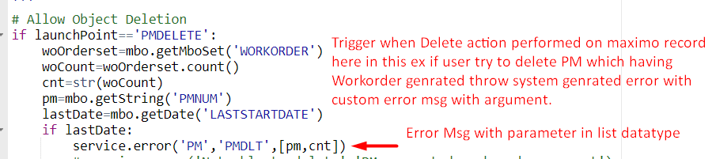
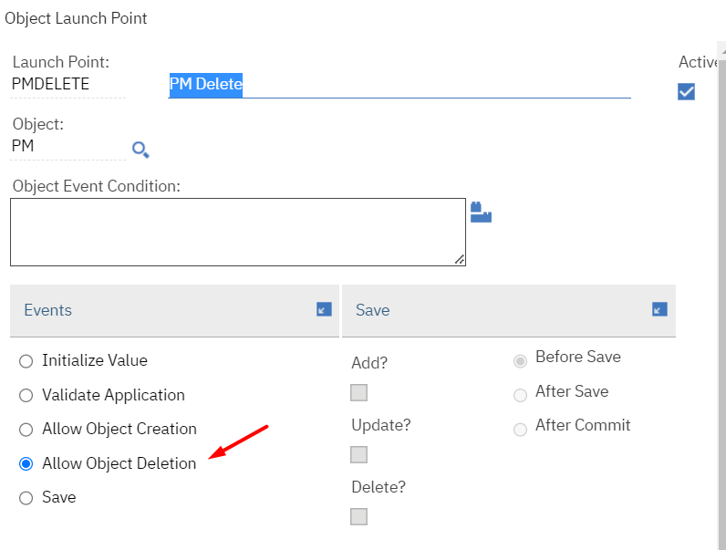
Custom message using database.
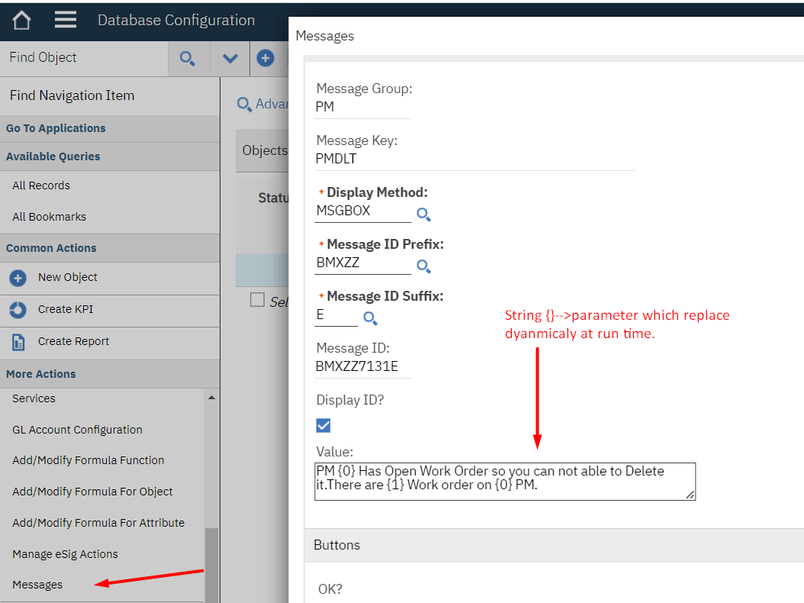
Output since two WO already generated on WO
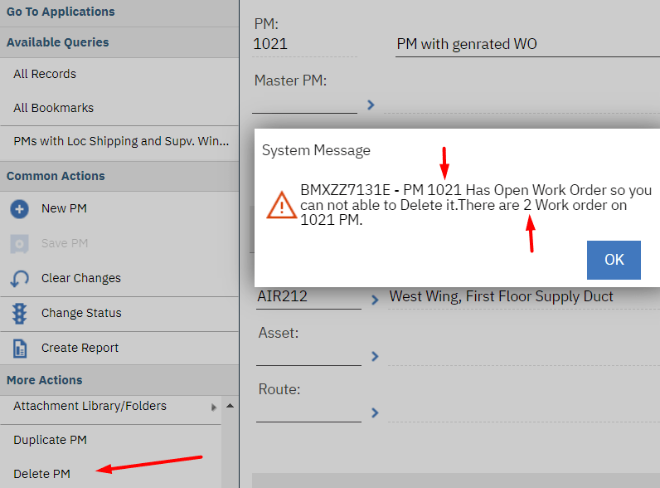

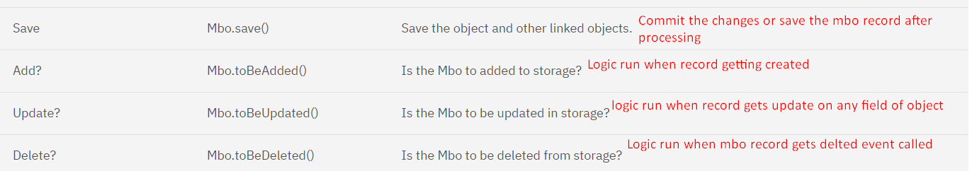
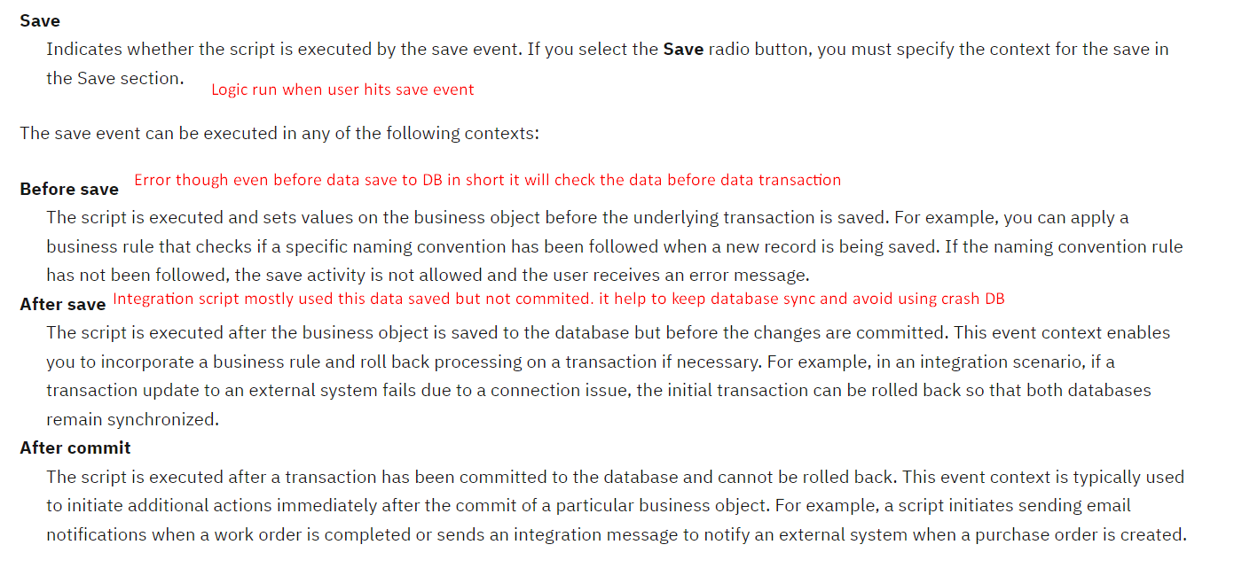
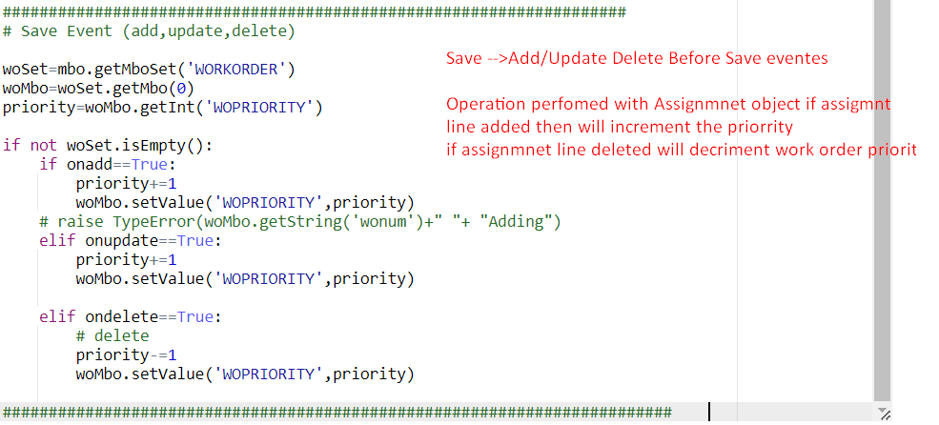

Before Save 🡪 Application Validation WOTRACK Location / Asset Required anyone.
After Save 🡪 To trigger the Publish Channel once the record saved in Database (insert/update)
After commit 🡪 To send the Communication template / Email SMS once all related object data placed in Database.
Attribute Launch Point
-Script trigger only when something happens on that attribute.
Event –
Initialize Access Restriction - init() 🡪 we can set the restriction to field and field become hidden when creating new record. Just like data restriction.
Help to set the access restriction on the attribute whenever record open
Use case user will be restricted to become updating the priority on record.
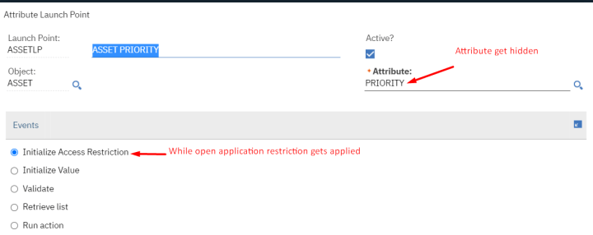
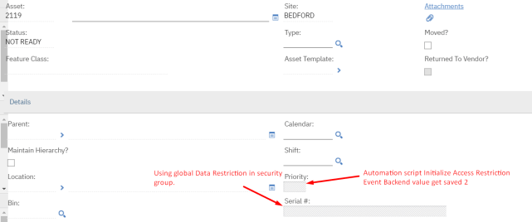
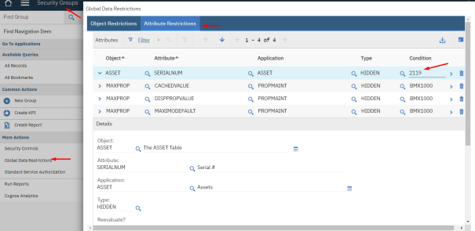

2. Initialize Value - initValue()🡪 While creating a new record script triggers and run logic and not run on save .and if user remove value and field is required from init value system validate at time save record.
We can make readonly, required.
3.Validate() 🡪 system will validate the business logic before transaction complete in DB
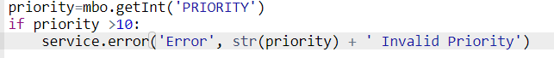
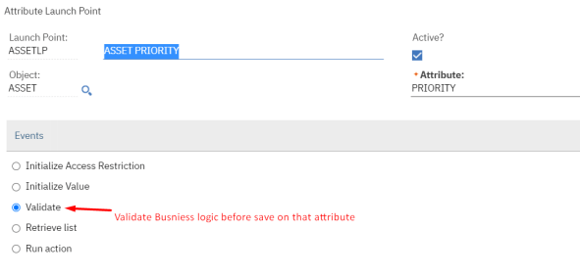
Retrieve list 🡪 Retrieves a list of valid values for the attribute's field. As per list where clause
Table domain
Run action 🡪 Run the business logic when record get saved. If error does not exist record gets saved.
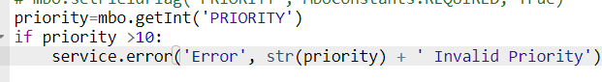

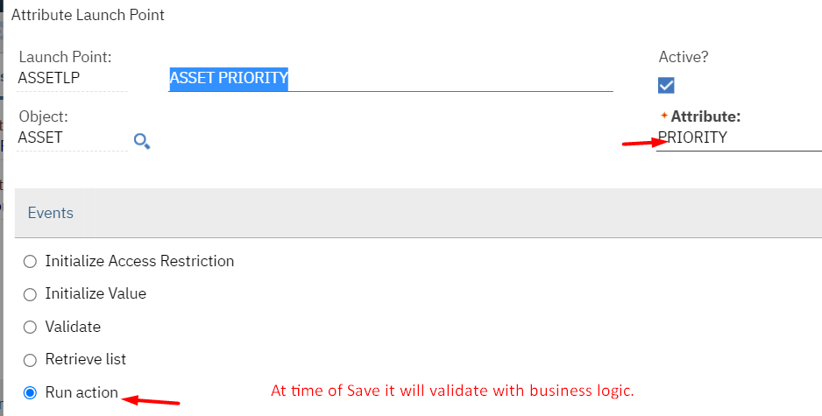

Action Script-> used for escalation workflow record processing. Invoking action from UI
Evaluate script and perform action on the record using escalation Action will be created from launch point name of LP and action must be same to avoid conflict.
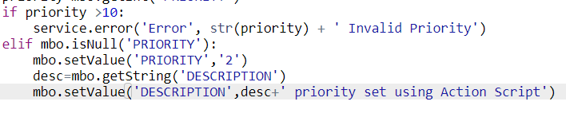
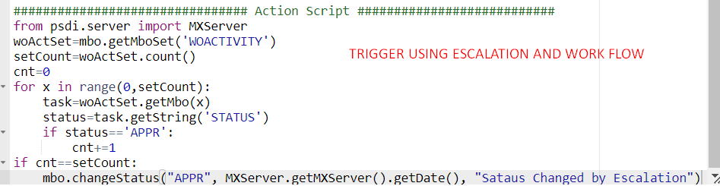
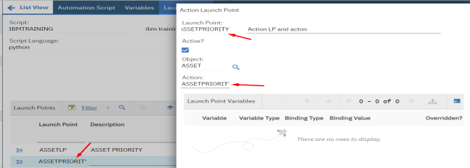
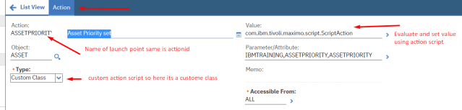
Create Escalation in following way
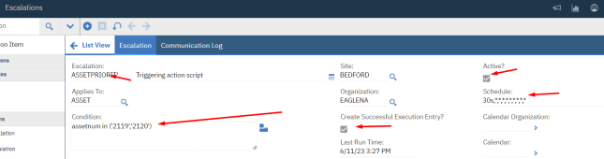
At least one escalation point with blank condition
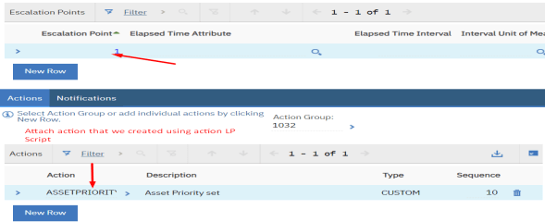

Validate and Activate escalation.
Output result
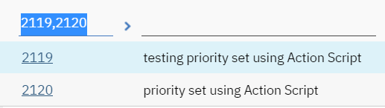

Custom Condition Launch point script 🡪 we can evaluate the script logic result to true and false and that can be used in the conditional expression manager so that condition expression manager act as sql mean return eighter True or False result.
We can use this condition in workflow or in security restriction.
priority=mbo.getInt('PRIORITY')
if priority==5:
evalresult=True
else:
evalresult=False
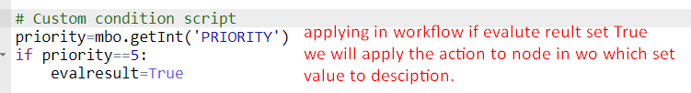
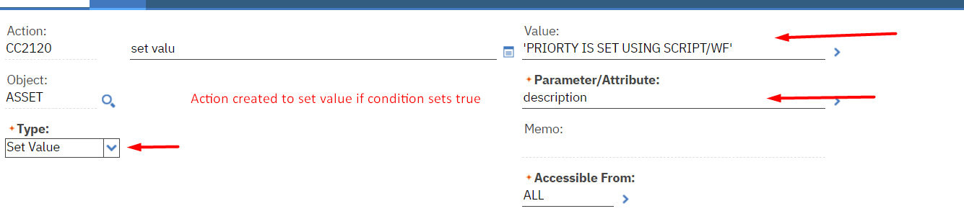
Creating and attaching action to WF
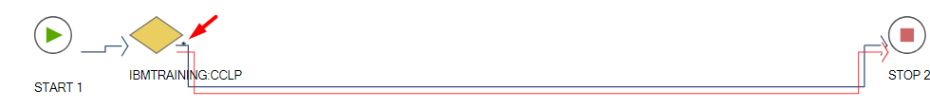
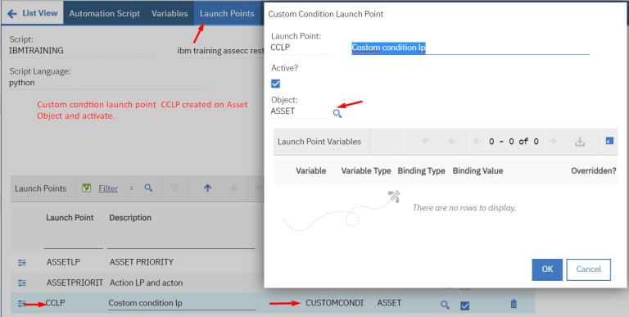
Created a Condition as follow.
Classname= com.ibm.tivoli.maximo.script.ScriptCustomCondition
Expression =scriptname : launchpointname
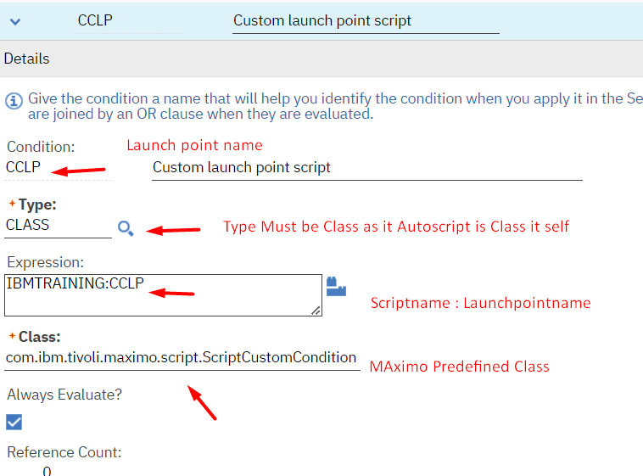
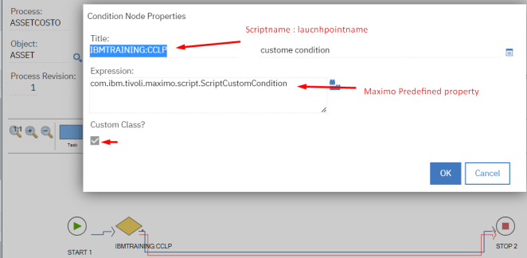
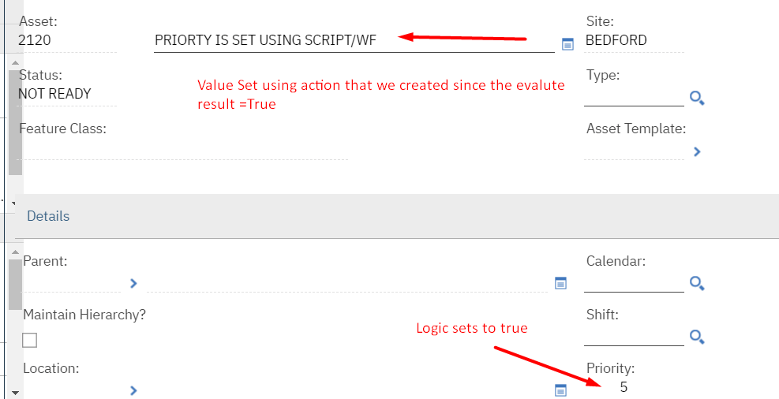

2. Hide new row button for child table
Create cust condition LP script on main object
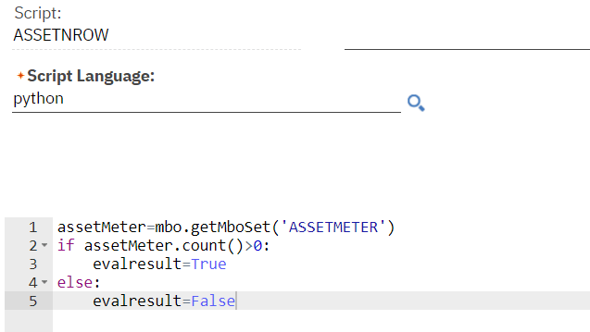
LP
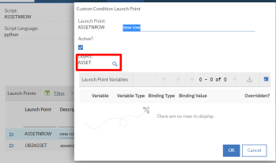
Create a condition of it
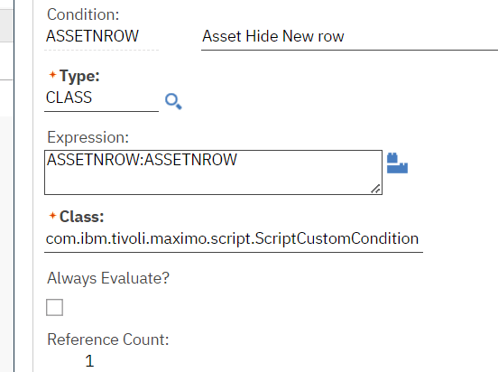
Create a sig option and applies on new row button and configure sig option property grant security group access.
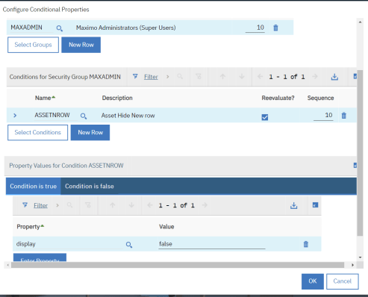
Must use MAINRECORD in the sig option data source.

Cron Task Script
######################Cron task set up (Script)##############################
It is used to schedule task just like escalation

Reference : https://a3jgroup.com/2018/04/12/run-an-automation-script-from-a-cron-task-in-maximo/

#######################
# Script to generate an SR for a monthly equipment audit Normal Script no LP
#######################
from psdi.server import MXServer

# Get the variables from the cron task arguments
srDesc = 'Monthly Equipment Audit'
instanceName = 'WILSON'
if arg:
srDesc,srOwner,srReport,srSite = arg.split(',')

# Create the SR
srSet = None
try:
srSet = MXServer.getMXServer().getMboSet('SR', runAsUserInfo)
srMbo = srSet.add()
srMbo.setValue('DESCRIPTION', srDesc)
srMbo.setValue('OWNER', srOwner)
srMbo.setValue('REPORTEDBYID', srReport)
srMbo.setValue('siteid', srSite)

srSet.save()
finally:
if srSet:
srSet.close()

#######################
# End of Script
#######################

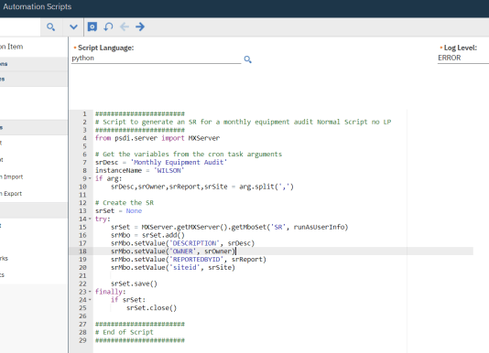

Cron Task Set up class is important.

Class: com.ibm.tivoli.maximo.script.ScriptCrontask

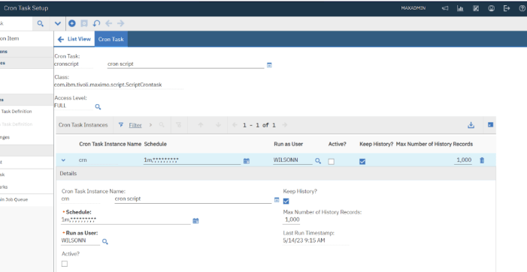

Arg mean our variable value that we are passing vai argument
Script name mean this cron run that script as action
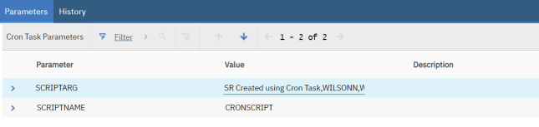

Expected Output
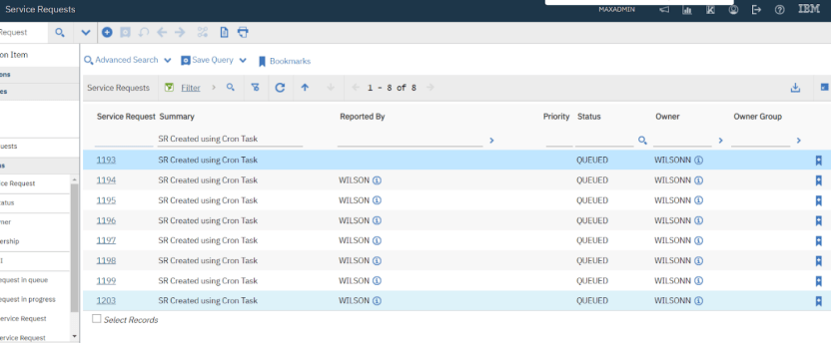

Implicit variable
https://www.ibm.com/docs/en/mam/7.6.1?topic=scripts-implicit-variables

Maximo Procurement
Maximo Organization application access.
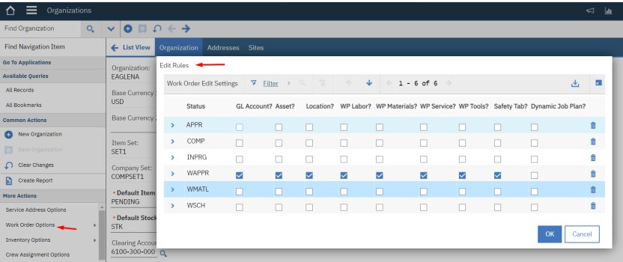
Here what are all field are editable in what status we can determine.
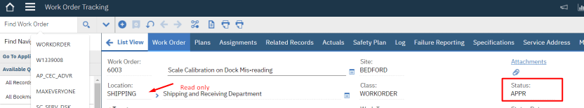
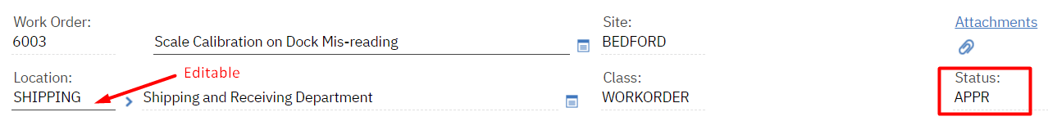

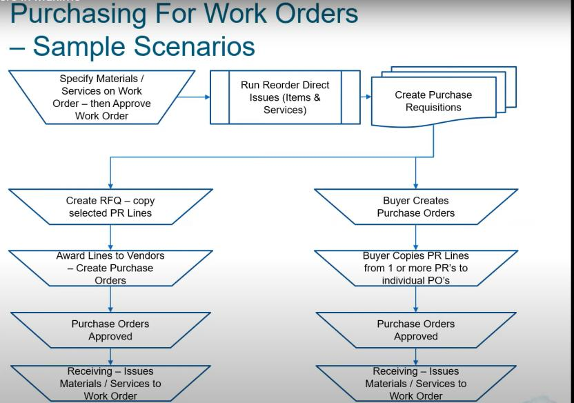

Issue item material or service to WO(APPR) --> Indirect issue charge against storeroom
PR- PO - RECEVE-Change inspection status -(store)--INVENTORY-issue current item --> WO-->Actual tab
Once we approve the PR and create PO from its PR line gets copied over the PO line and PR gets CLOSED
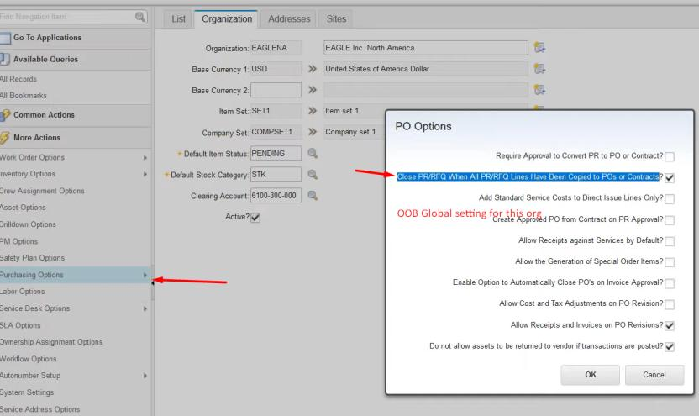

Direct issue --> PO(charged against WO not storeroom) -- receive --> change inspection status
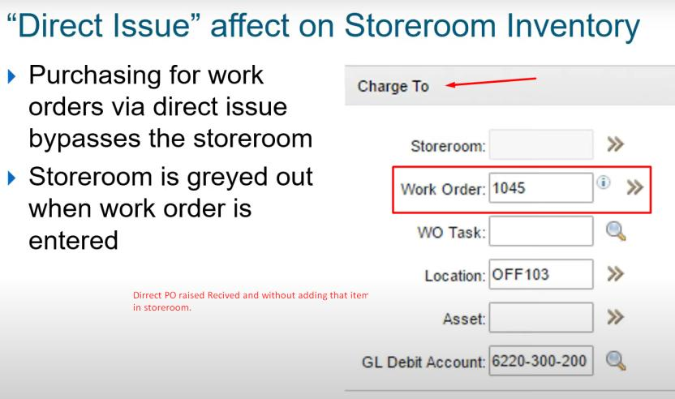

Contract
reference https://www.gomaximo.org/wp-content/uploads/2018/01/2018-GOMaximo-Maximo-Contracts-Cohesive.pdf

Master Contract 🡪
- Associate multiple contract for same vendor using this application
Blanket Contract 🡪 A blanket contract is a purchasing agreement that your organization makes with a vendor to pre-plan the purchase of materials or services, We can create release PO payment schedule
GL Account is specified in PO, not in Contract because contract is an agreement between the operating company and a 3rd party vendor; it is generally to define terms and conditions, and set a fixed price for certain goods or services.

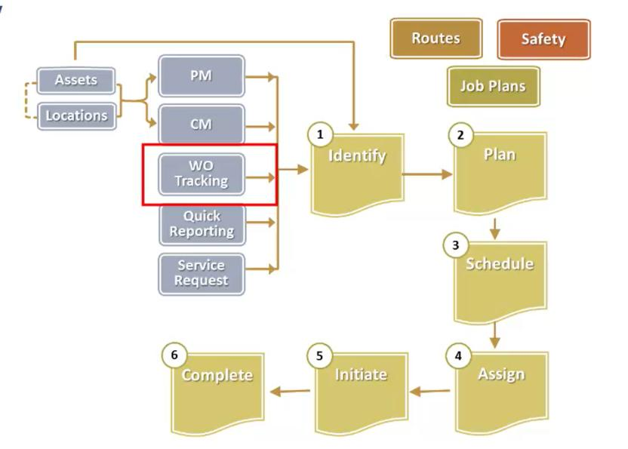
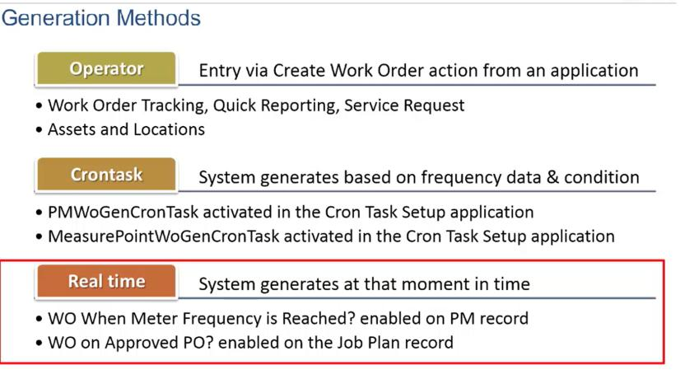

Maximo Integration Framework
MIF Allow us to exchange data between external application and Maximo which is in real time.
Using variety of communication protocol.
Ex. If Mobile engineer using mobile device (Cognito) on complete work order that data gets back in Maximo using Maximo integration. --> Enterprise service MAXIMO 🡪 ACE 🡪 Cognito
Data Mapping will take care by middle ware ACE tool (IBM Integration tool)
ACE 🡪 App Connect Enterprise
If any work order created in Maximo for engineer using another device like Cognito will get notified 🡪 (Publish Channel) work order, will be received by Cognito.
External system 🡪 Allow Maximo to consume the data. Using web service XML that is deployed.
Service 🡪 inbound Integration 🡪enterprise service (in Maximo), External system (in system)
Channel 🡪 Outbound channel 🡪(publish (async) invocation (sync))

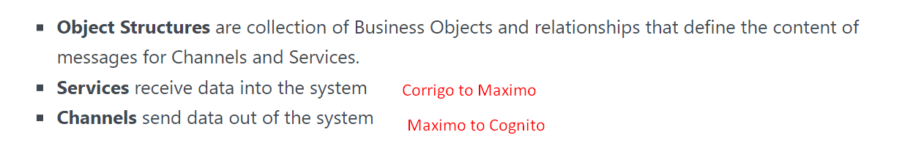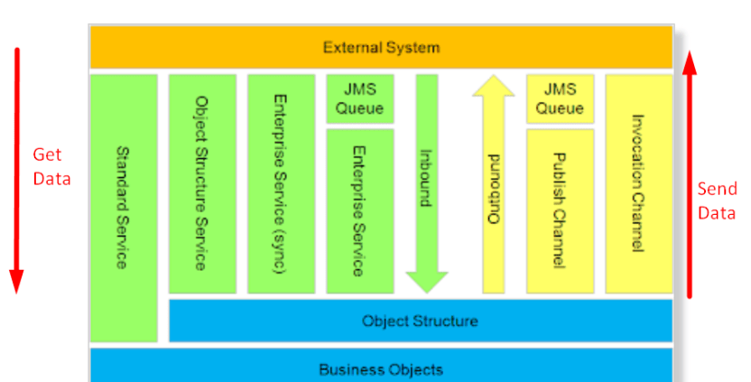

Object Structure : Allow Data travel in maximo as well we can call retrive thoes data from maximo to outside of maximo using object structure. MxLoader. Which allow CRUD data using object structure service.
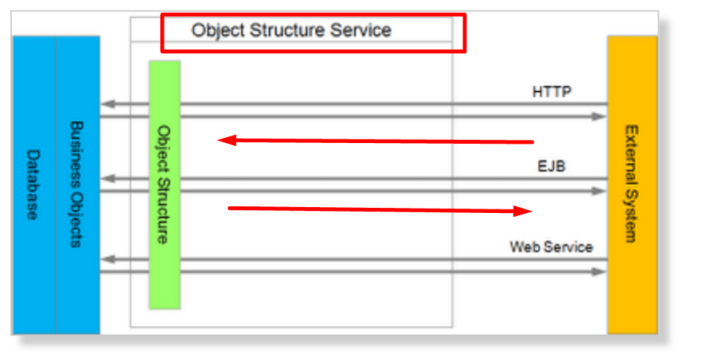

Data transaction flow
Application To External system (async not real time) 🡪 Application 🡪 queue 🡪External system
External System To application 🡪External system🡪 queue 🡪 Maximo application

Synchronous processing allows a real-time connection between the two systems. Whenever a transaction is sent from the application, it is immediately received by the external system. If a transaction is sent from the external system, it will be immediately received by the application. Synchronous processing requires that both systems be running.
In sync data will not flow from queue.
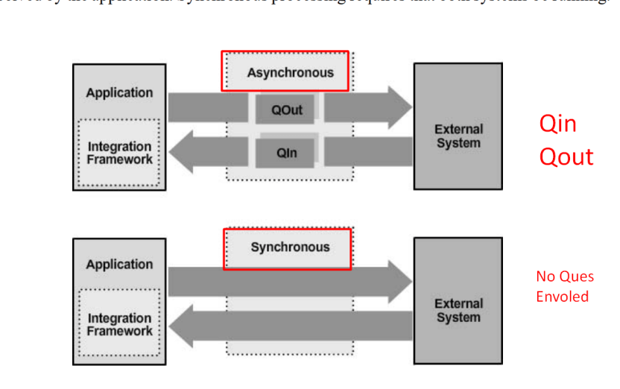
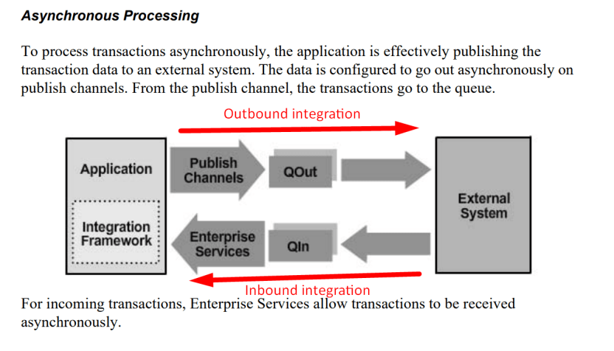

Synchronous Data process does not involved any queue in there transaction system to system data transaction.
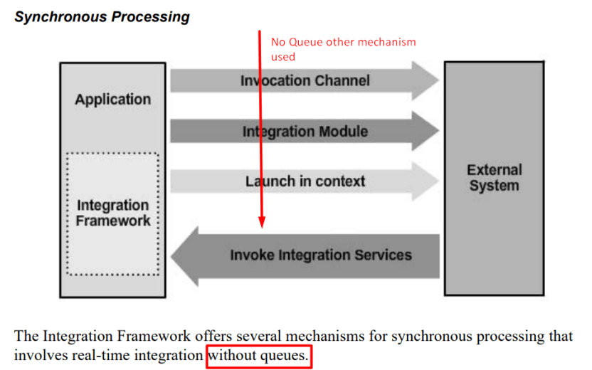
invocation channel —> Application 🡪 system 🡪 system return response to application.
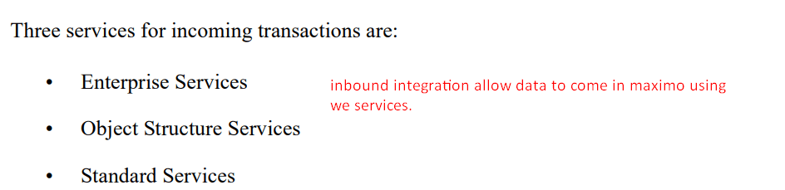

Enterprise service 🡪 it used object structure and on this enterprise service we can set the data processing rule while external system sending data in Maximo.
The Object Structure Services use the object structures directly.
Standard Services allow calls to service methods that are part of the Base Services. When Maximo Asset Management starts, several services are logged to the console during startup. Methods in those services are exposed and can be called.
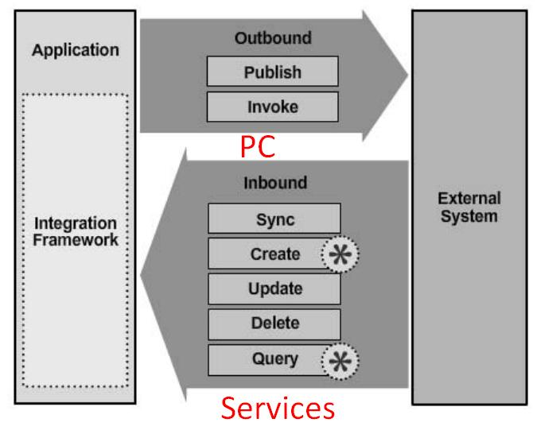
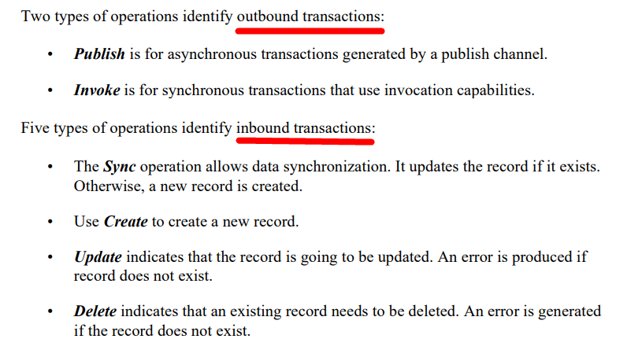
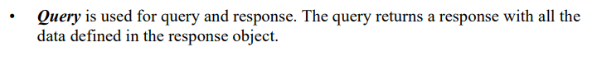
Inbound and outbound queues
Queues used as Staging area during data exchange between Maximo – External system or vise versa
Maximo Manage uses one queue for outbound processing and two for inbound processing.
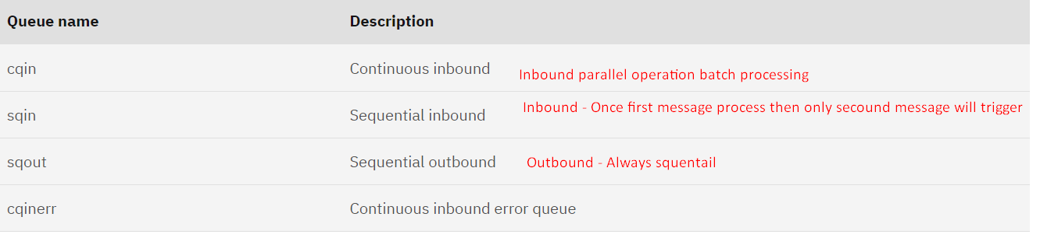
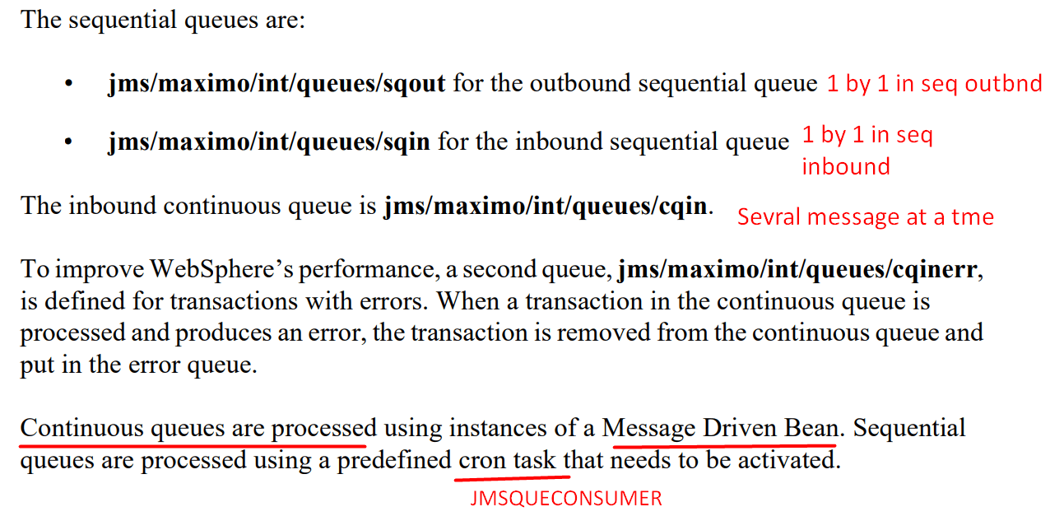
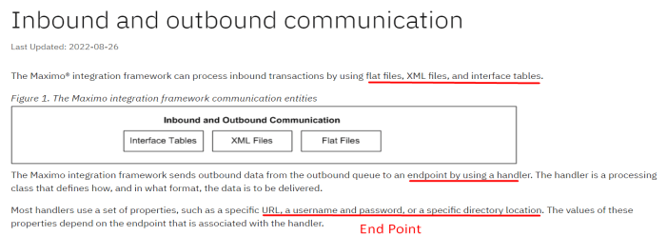

Integration can we achieved using various mode –
HTTP call /Rest Call
Enterprise service
Interface Table
Interface tables are an option for integration with systems that use database tables to exchange data. This integration option applies only to enterprise services and publish channels and is always processed asynchronously, by using JMS queues.

Handler 🡪 we can configure the end point using handler
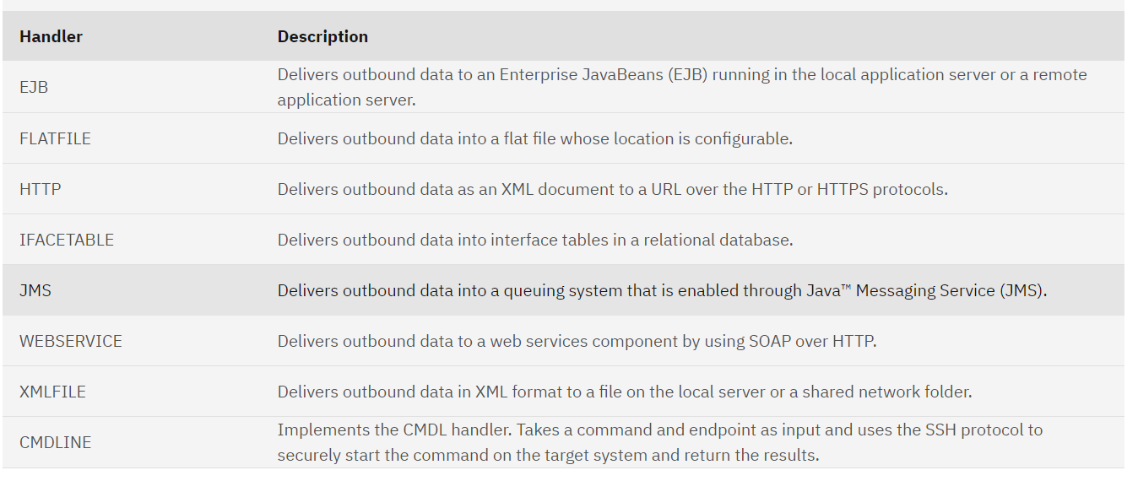

Integration System property mxe.int.dfltuser -Defualt user – mxintadm
Cron Task for Integration – JMSQSEQCONSUMER 🡪 This cron task have both SQQIn and SQQOut
Integration Component
Object Structure 🡪 bind multiple objects on the basis of object relationships. Which help to communicate the data means we can query data as well as update data (GET/POST)
Channel and services -> channel helps to publish the data outside 🡪 there are two type of channel (publish -Async uses Ques) and invocation channel (sync integration ques not involved and get response from external system if msg process)
Three types of service process inbound messages; object structure services, enterprise services(after creation of enterprise system), and standard services.

End Point -> Handler for outbound messages which need to bind to an external system. It acts as URL which contains all POST request required header property to publish data.

External system 🡪 application allow us to build protocol to communicate between Maximo and x system. Were we can define enterprise service (which takes data from ext. system) and publish channel (send data from Maximo)
Alternate Key in Object structure- something which unique for external systems its nothing but the index from the object.
When the external system sends any data to Maximo (Inbound) Maximo need to identify before consuming it.
An alternate key is set up at the object level or at the object structure level if it sets at the object level all object structures which contain that object will use that alternate key, and if we select at object structure level it will only limit object structure.
You must select the Flat Supported check box for any object structure that you intend to use for interface table or flat file integration scenarios. When this option is set, messages are checked to ensure that every column for every object in the object structure has a unique name.
Query Only Object structure 🡪 If the object structure is intended for querying only and you do not want to use it for updating, select the Query Only option.
To avoid the unique col value from integration we will use inbound restriction by checking check box.

Channels and services
Publish Channel -- publish channel is used for sending asynchronous messages through a JMS queue to an external system. Publish channel messages can be initiated via an event or through the Data Export feature.
Event Lister -- enable an event listener on a publish channel to monitor for processing activity on the associated publish channel objects. Publish channel processing is initiated when an event occurs on the main object of the associated object structure.

Communication Template 🡪 used to send outbound emails from Maximo mainly used in escalation, workflow, and application action also can be used by Maximo automation script.
Com template accessible from


